Children & Young People’s Bulletin 
Week Beginning: 27th April 2026

Hello everyone,
We hope you’ve had a great week! Here’s your latest update, including service developments, activities, and opportunities happening locally and nationally 🌼

💛 Thank You – CYP Service Poll
A big thank you to all children, young people, parents and carers who have already contributed to our CYP Service Poll 🙌
Your views are incredibly important and will directly shape the future of our service.
📝 If you haven’t yet taken part, there is still time!
The poll will close on Friday 30th April.
👉 Please support this – your voice will help us build a service that truly meets your needs. I can resend the poll by request.

🚀 Coming Soon to CYP Service
We are excited to begin introducing new elements to our Children & Young People’s offer:
✨ 1:1 Support for CYP & Families
Personalised guidance, listening support and advice
🌙 Evening Sessions
Safe, social spaces for young people to connect and take part in activities
🎯 Saturday Activity Sessions
Fun, inclusive sessions designed with young people in mind
👉 More details coming soon – shaped by you!

📅 Save the Dates for Your Diary
Please keep these important upcoming dates in mind:
📌 May Half-Term Activity
🗓 Friday 29th May 2026
🔥 Croydon Vision Summer BBQ
🗓 Friday 24th July 2026
👉 More information and booking details will be shared soon!

🌟 This Week at Croydon Vision
This Week at Croydon Vision
💻 Tech Time: Digital Detectives Club
Calling all young tech explorers!
Join our Digital Detectives Club, where you can:
• Build computer and digital skills
• Try educational games
• Develop touch typing
• Explore accessible technology
• Take on fun challenges
Whether you’re new or confident with tech – everyone is welcome!
📩 Contact Daniel for more information:
daniel.ojobo@croydondropin.org.uk

📍 Local Activities (Croydon & Nearby)
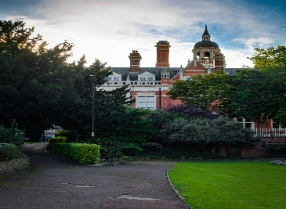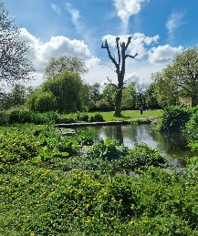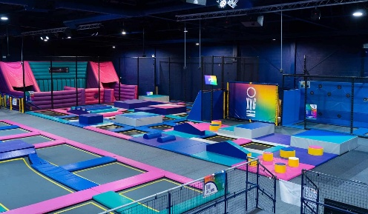

• 📚 Storytime & family sessions at Croydon Clocktower (Library & Museum)
• 🌳 Outdoor walks and play at Wandle Park
• 🤸 Trampoline fun at Flip Out Croydon
• 🧗 Indoor activity park at Oxygen Freejumping Croydon
• 🧸 Soft play centres across Croydon
👉 Tip: Search the activity name online for booking details and accessibility information.

🇬🇧 National & Online Activities
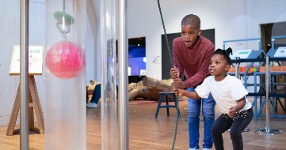

Explore these trusted organisations:
• 🌿 Family days out with the National Trust
• 🔬 Interactive galleries at the Science Museum
• 🧠 Learning resources on BBC Bitesize
• 🖼 Virtual tours via the Natural History Museum
• 👁 Support and activities from Royal National Institute of Blind People
👉 Visit their websites to explore activities, book visits or join online sessions.

🌈 Help Us Plan – May Half Term & Summer
We’d love your ideas! 🙌
🌟 Activity Ideas So Far
🏖 Littlehampton Beach Trip
🌳 Picnic in Battersea Park
🚤 Thames Boat Trip (Greenwich / Kew)
🧗 Clip ‘n Climb
🎳 Bowling
🏊 Guildford Spectrum
🧪 Gootopia slime experience
👉 Let us know what you’d like to see!
Your ideas will help shape a fun, inclusive programme for everyone.

Together we can build a service that is inclusive, creative, and shaped by young people’s voices 💛
Have a wonderful week — we look forward to seeing you soon!
Angela Ben-Arie
Children & Young People’s Engagement Coordinator
Croydon Vision
📩 Contact Us:
Angela: angela.b.arie@croydonvision.org.uk
Sarah: sarah.morgan@croydonvision.org.uk
Daniel: daniel.ojobo@croydondropin.org.uk
📞 Reception: 020 8688 2486
📱 X: @CroydonVision
📸 Instagram: @croydon_vision
💛 Please consider donating:
https://www.justgiving.com/campaign/croydon-vision-bridge-the-gap

