Working Age Bulletin

Wednesday 20th May 2026

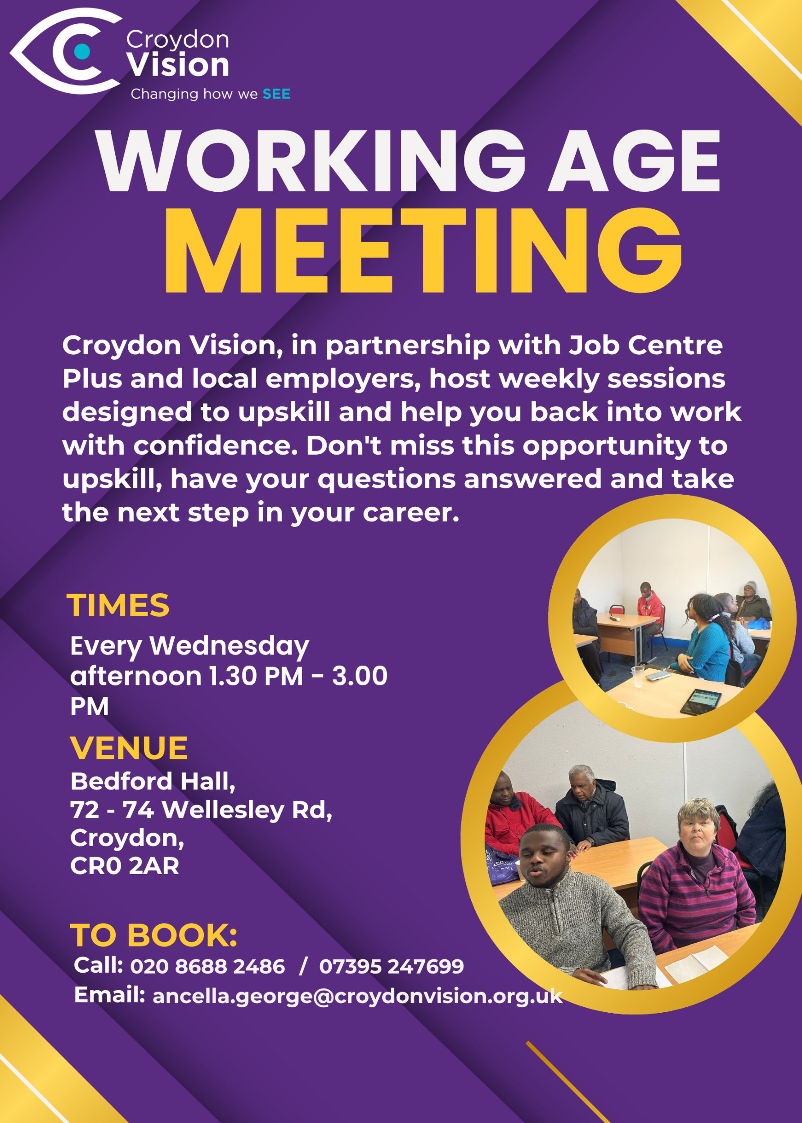


JustGiving fundraising Appeal Link:
https://www.justgiving.com/campaign/croydon-vision-bridge-the-gap
Weekly Meetings:
Bedford Hall 1.30pm – 3.00pm every Wednesday. Please arrive at 1.15pm for tea and coffee.

WAG Timetable:
Monday
ESL: 10.30am – 12.30pm – Bedford Lounge
Braille: 1.30pm – 3.00pm – Second Floor
Tuesday
Braille: 10.30am – 12.30pm – Second Floor
Book Club: 1.30pm – 3.00pm – Second Floor
Wednesday
Braille: 10.30am – 12.30pm – Second Floor
Craft: 11.00am – 1.00pm – Lounge Area
WAG: 1.30pm – 3.00pm – Bedford Hall

Itinerary for May:
20th May | Presentation: JCP DEA: Health Adjustment Passport
27th May | Presentation: AI Ethics (Advantages and Disadvantages) - Alexej

Stella Willow’s Workshops: - Posters attached
Mindfulness & Meditation Class (twice monthly) - £3.00 per session
What is Mindfulness and how can we find peace and contentment in the here and now?
Monday 1st and 15th June (11.00am -12.00noon)
Monday 6th and 20th July (11.00am -12.00noon)

Creative Writing Class
Mon 22nd and 29th June 10.30-12.00 noon - (£5.00 per session)
Every blank page is full of potential. No experience needed, just willingness to think creatively and enjoy!
We use techniques of automatic writing to liberate our inner creativity as Stella pens your stream of consciousness.

Verbatim Theatre Workshop
Monday 13th and 27th July 10.30-12.00 noon – (£5.00 per session)
Come and create a powerful play using our own experiences and stories to be told.

Fantastic Funded Travel Opportunity: Final Call
Six Days Independence Building Adventure to Sicily - FOR YOUNG ADULTS (18–25) WITH A VISUAL IMPAIRMENT. We are looking for young adults with a visual impairment to grow their confidence, sharpen their travel skills, and experience the rich culture of Italy. This project is more than just a holiday; it is a chance to gain vital life skills in a supportive yet challenging environment. Because this project is funded, the majority of your trip is covered.

Regional Funding Requirements:
Due to specific regional funding, we are seeking 16 participants in total:
- 8 people from Dorset and Hampshire
- 8 people from anywhere else in the UK
If you know anyone that meets these requirements, please send this email to them.

Trip Details:
- Dates: 31st October to 5th November 2026
- Participant age: 18 to 25 years old
- Location: Sicily, Italy
- What is covered: The funding covers your accommodation, planned excursions, lunches, dinners, and expert guiding.
- Participant responsibility: Participants are responsible for booking their own flights and travel insurance, and for purchasing their own breakfast groceries at the destination.

Pre-trip Commitment:
To ensure you feel prepared and empowered, all participants must attend a virtual five-session travel independence course on the following dates:
- 4th June
- 2nd July
- 6th August
- 1st September
- 1st October

Contact us Today: If you are ready to manage your own personal care, navigate new spaces with your mobility aids, and build lasting connections with a group of like-minded peers, this is your moment. We are finalising selections the week commencing 18th May.
This project has been funded by the Powell Foundation and DHB Events.
- Phone: 020 3375 6947
- Email: info@seable.co.uk
BBC1 Sort Your Life Out! - A message from the Production Team
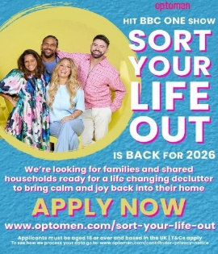

Flyer with Stacey Solomon and three co-presenters. Text says "Optomen hit BBC One show Sort Your Life Out is back for 2026. We're looking for families and shared household ready for a life changing declutter to bring calm and joy back into their home. Apply now www.optomen.com/Sort-Your-Life-Out Applicants must be aged 18 or over and based in the UK | T&Cs apply. To see how we process your data go to: www.optomen.com/contributor-privacy-notice

Hello, my name is Claire and I’m part of the casting team working on the hit BBC1 show Sort Your Life Out!

We are currently looking for families or shared households that need help decluttering their homes and transforming their spaces to take part in a new series.

We are particularly keen to connect with families where someone is navigating changes in vision and who may be thinking about how their home might need to be adapted for the future.

Through the programme, we plan to offer support and sensitively raise awareness of the different pressures people face.

To find out more, please visit the Sort Your Life Out website.

VocalEyes News:
Leaping into the park on Saturday 5th September is a new production of Andrew Lloyd Webber’s Cats. Join the strays and rebels of London gather under the Jellicle moon in the hope they’ll be the chosen one. Featuring a legendary score including Old Deuteronomy, Macavity: The Mystery Cat, Jellicle Ball and the chart-topping hit Memory. You can book tickets on 0333 400 3562 or email: boxoffice@openairtheatre.com.

Press Release:
*This Sound Is Purple launches debut exhibition at SQFT Space, pairing contemporary art with narration, artist reflection and sound

Exhibition Dates: 8 May – 11 June 2026
Venue: SQFT Space, Marylebone, London
Admission: Free
This Sound Is Purple launches its debut exhibition at SQFT Space, Marylebone, from 7 May to 11 June 2026. Bringing together contemporary art, narration, artist reflection and original sound, the free exhibition invites audiences to experience visual art in a more immersive, accessible and emotionally resonant way.
Featured artists include Bianca Raffaella, Peter Davis, Ray Richardson, Danny Rolph, and Jennifer Farrow-Moore. Mini Interview with Glenn Harvey.
Dr Peter’s Corner:
Part 2 of Dr Peter’s write up is attached. Please feel free to share his write up and email me any questions you may have for him.

Dates for your Diary:
Metro Sports – 13th June
Vision Zone – 23rd June
CV Barbecue – 24th July

Update from Visionary:
Why is a form of Vitamin B3 being tested in glaucoma clinical trials?
20 May, 12 PM to 1 PM
Glaucoma is one of the leading causes of blindness and visual impairment, affecting around 80 million patients worldwide. It’s also one of the most common neurodegenerative diseases.
Currently, the only approved way to manage glaucoma is through lowering pressure in the eye, but these treatments don’t work for everyone, and they don’t address the neurodegeneration that is a hallmark of the disease. That’s why recent research has investigated the potential therapeutic effects of something called ‘nicotinamide’ (otherwise known as NAM; a form of vitamin B3 that’s found in the diet or supplements). To put it simply, NAM can help to increase the amount of energy our cells have.
For this webinar we will be joined by Professor Ted Garway-Heath from UCL, and Associate Professor Gerassimos Lascaratos, who have been funded by Fight for Sight for their work on glaucoma. Register here: Why is a form of vitamin B3 being tested in glaucoma clinical trials? | Zoom.

Metro Games 2026:
13 June, 10.30 AM – 5.30 PM, London
Metro Blind Sport is delighted to announce that sign-up for Metro Games 2026 is now officially open. This much-loved annual event is a highlight in our calendar - a fantastic, high-energy day bringing our community together to take part in a wide range of traditional athletics activities. Whether you are looking to compete, try something new or simply enjoy the atmosphere, the Metro Games promises an inclusive, exciting and memorable experience for all.
Event Details
- Date: Saturday 13 June 2026
- Time: 10:30 AM – 5:30 PM
- Location: Mile End Stadium, 190 Burdett Road, London, E14 7TW
- Nearest Station: Mile End (Central, District & Circle Lines)
- Activity: Track and Field Athletics Events
- Cost: Free
- Meet & Greet: Available at Mile End Station

A: Bedford Hall, 72 - 74 Wellesley Road, Croydon, CR0 2AR
T: 020 8688 2486; Mob: 07395 247 699
E: ancella.george@croydonvision.org.uk | W: www.croydonvision.org.uk
Donate with JustGiving: https://www.justgiving.com/campaign/croydonvision



