Working Age Bulletin

Wednesday 6th May 2026

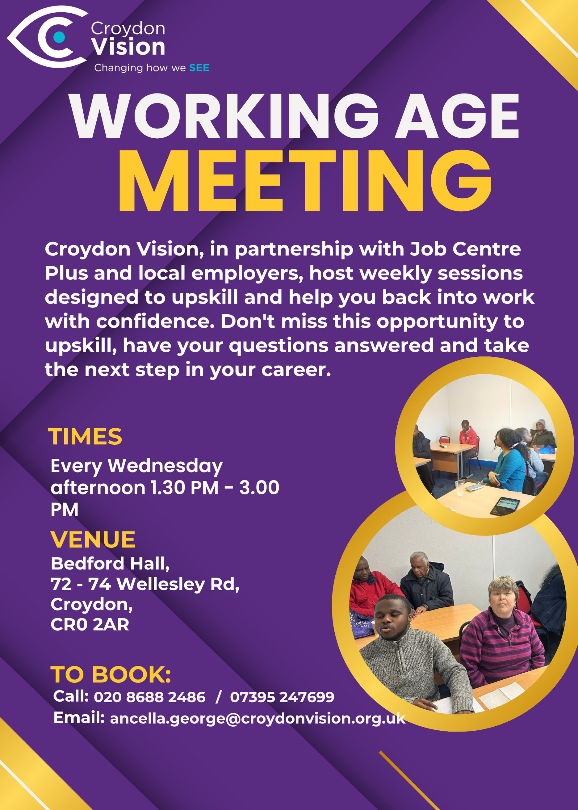
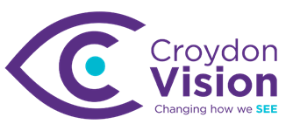


No Mountain Needed: The Stairway to Everest Challenge justgiving.com

Please support a worthy cause

Weekly Meetings:
Bedford Hall 1.30pm – 3.00pm every Wednesday. Please arrive at 1.15pm for tea and coffee.

WAG Timetable:
Monday
ESL: 10.30am – 12.30pm – Bedford Lounge
Braille: 1.30pm – 3.00pm – Second Floor
Tuesday
Braille: 10.30am – 12.30pm – Second Floor
Book Club: 1.30pm – 3.00pm – Second Floor
Wednesday
Braille: 10.30am – 12.30pm – Second Floor
Craft: 11.00am – 1.00pm – Lounge Area
WAG: 1.30pm – 3.00pm – Bedford Hall

Itinerary for May:
6th May | Presentation: JCP (DEA): Autism Voice – Mariama (Wellbeing Workshop)
13th May | Presentation: Session 2 - Micro Enterprise Community with Connect to Work (Sasha and Paul)
20th May | Presentation: JCP DEA: Health Adjustment Passport
27th May | Presentation: Croydon Centre Development and Heritage Team

Blind Ambition News:
New Recruitment site launches for VI Jobseekers
Blind Ambition has launched a brand-new recruitment site designed specifically to connect inclusive employers with blind and partially sighted job seekers. Built from the ground up to be fully accessible, every feature ensures a seamless experience for visually impaired candidates. Employers benefit from reaching motivated talent, while job seekers can apply with confidence knowing the opportunities listed are from organisations committed to inclusion. Explore the new site today at recruitment.blindambition.co.uk.

IT Training:
Blind Aid is offering IT training for Croydon residents. Three of our WAG members have successfully enrolled for the current cohort which started two weeks ago. If you would like to be registered for the next Cohort that starts in July, please let me know as soon as possible. Places are limited and in high demand.

Soulful Purpose:
This is a space on George Street where you can go for a cup of coffee and enjoy different activities taking place. The space is useful for using your skills to volunteer to run a workshop or collaborate with the organisers of the charity to showcase your skills and talents. Please contact me if this appeals to you and I will organise with Orline for you to have a visit.

2027 Seable Group Holiday Release coming soon:
Following the incredible success of our 2026 season, we are excited to announce that we will very soon be releasing the first batch of our 2027 group holidays. While the official dates are coming soon, we couldn’t wait to share a sneak peek of the destinations we have lined up for you:

• Long Haul Adventures: Colombia, Japan, and Thailand
• European Group Favourites: Vienna, Venice, Rome, and Naples
• UK Multi-city Tours: London and Edinburgh
• Themed Getaways: Wine Tour, Yoga Retreat, Disneyland Paris, and Berlin Xmas Markets

Our group departures are unique and highly sought after, with spaces being snapped up almost as soon as they are released. We highly recommend that you wait for our upcoming announcement before making any other travel plans for next year. We want to make sure you don't miss out on the specific Seable experience you've been waiting for!

To ensure you are at the front of the queue for our 2027 release, register your interest now. You will be the first to receive the official dates and booking details.
• Call us: 020 3375 6947
• Email: emma.s@seable.co.uk
2026 Community Internship Programme
Projective Group UK is proud to announce the implementation of our new Community Internship Programme, designed to support and engage local talent.

The Community Internship Programme is designed to provide individuals with an insight and practical exposure to financial consultancy. The Programme aims to support participants in accessing and sustaining meaningful work experience within the industry. It will run for one week during the week commencing 10th August from our office near London Bridge.

This will be an unpaid internship, open to candidates aged 18 and above. All travel and food costs will be covered as part of this internship. The office attire is business casual. You will be supported by a buddy who will be there to answer any questions, and you will also have access to employees across the business.

Application process:
Please see attached leaflet on how to apply.

May 2026: Observances
Key Bank Holidays & Public Holidays
Monday 4 May: Early May Bank Holiday (May Day)
Monday 25 May: Spring Bank Holiday

Key Awareness & Special Days:
7 May: World Password Day
10 May: World Lupus Day
12 May: International Nurses Day
11-17 May: Mental Health Awareness Week
12-18 May: ME Awareness Week
16 May: World Whisky (Whiskey) Day
17 May: World Baking Day
18-24 May: Breast Cancer Prevention Week
20 May: World Bee Day
21 May: International Tea Day & Ascension Day
22 May: National Beer Garden Day
24 May: Pentecost
26-30 May: Eid ul-Adha (observed)
25-31 May: National BBQ Week

Dr Peter’s Corner:
Dr Peter’s write up on ‘Spring and your Eyes’ is enclosed. Please feel free to share his write up or email me any questions you may have for him.

Excursion:
We will be heading to Coombe Lodge near Lloyd’s Park on Thursday, 7th May for a lovely meal and chitchat. This will be a combined trip with other members and staff of Croydon Vision. Please arrive at Croydon Vision by 11.00am prompt. We will be going by the minibus.

Update from Visionary:
Why is a form of Vitamin B3 being tested in glaucoma clinical trials?
20 May, 12 PM to 1 PM
Glaucoma is one of the leading causes of blindness and visual impairment, affecting around 80 million patients worldwide. It’s also one of the most common neurodegenerative diseases.
Currently, the only approved way to manage glaucoma is through lowering pressure in the eye, but these treatments don’t work for everyone, and they don’t address the neurodegeneration that is a hallmark of the disease. That’s why recent research has investigated the potential therapeutic effects of something called ‘nicotinamide’ (otherwise known as NAM; a form of vitamin B3 that’s found in the diet or supplements). To put it simply, NAM can help to increase the amount of energy our cells have.
For this webinar we will be joined by Professor Ted Garway-Heath from UCL, and Associate Professor Gerassimos Lascaratos, who have been funded by Fight for Sight for their work on glaucoma. Register here: Why is a form of vitamin B3 being tested in glaucoma clinical trials? | Zoom.

Metro Games 2026:
13 June, 10.30 AM – 5.30 PM, London
Metro Blind Sport is delighted to announce that sign-up for Metro Games 2026 is now officially open. This much-loved annual event is a highlight in our calendar - a fantastic, high-energy day bringing our community together to take part in a wide range of traditional athletics activities. Whether you are looking to compete, try something new or simply enjoy the atmosphere, the Metro Games promises an inclusive, exciting and memorable experience for all.
Event Details
- Date: Saturday 13 June 2026
- Time: 10:30 AM – 5:30 PM
- Location: Mile End Stadium, 190 Burdett Road, London, E14 7TW
- Nearest Station: Mile End (Central, District & Circle Lines)
- Activity: Track and Field Athletics Events
- Cost: Free
- Meet & Greet: Available at Mile End Station
To secure your place, please complete the registration form linked here - Metro Games 2026 Entry Form (opens online form). The form includes full details about the event, as well as the range of activities you can take part in.
If you need any support with signing up, please get in touch - Fran is happy to help via phone on 07966 260 089 or email Fran (opens email).
Please note that Shalini will be taking a group to this event. Please contact her directly if you want to be added to the list.

A: Bedford Hall, 72 - 74 Wellesley Road, Croydon, CR0 2AR
T: 020 8688 2486; Mob: 07395 247 699
E: ancella.george@croydonvision.org.uk | W: www.croydonvision.org.uk
Donate with JustGiving: https://www.justgiving.com/campaign/croydonvision

