Working Age Bulletin

Wednesday 03rd June 2026

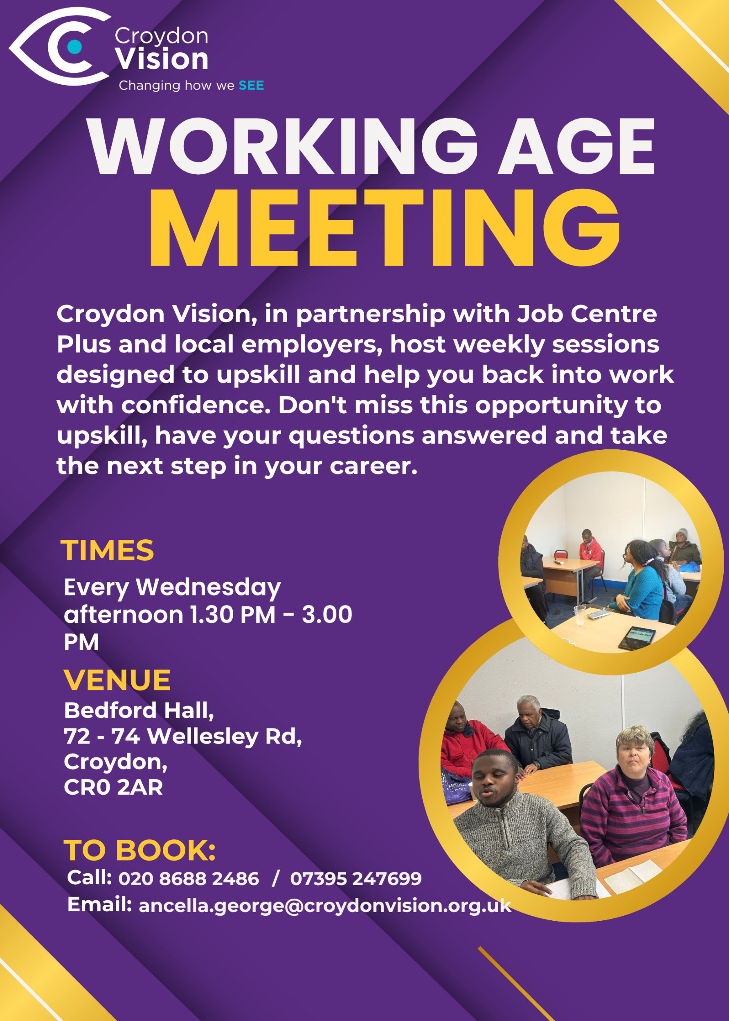
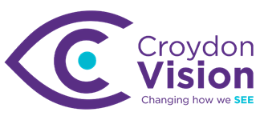

JustGiving Link:
https://www.justgiving.com/charity/croydonvisually
Weekly Meetings:
Bedford Hall 1.30pm – 3.00pm every Wednesday. Please arrive at 1.15pm for tea and coffee.

WAG Timetable:
Monday
ESL: 10.30am – 12.30pm – Bedford Lounge
Braille: 1.30pm – 3.00pm – Second Floor
Tuesday
Braille: 10.30am – 12.30pm – Second Floor
Book Club: 1.30pm – 3.00pm – Second Floor
Wednesday
Braille: 10.30am – 12.30pm – Second Floor
Craft: 11.00am – 1.00pm – Lounge Area
WAG: 1.30pm – 3.00pm – Bedford Hall

Itinerary for June:
3rd June | Croydon Commitment - Employability workshop Part 2
10th June | Presentation - Kelsey Trevett
17th June | Presentation – AI Ethics
24th June | Employment Program including registration with Ingeus

The Postal Museum Audio-Described Tour - Friday 3rd July
I'm Danny, a Learning Facilitator in the Access & Communities team at The Postal Museum. The Postal Museum explores over 500 years of social and communications history, and visitors can experience a ride through the tunnels of the old Post Office Underground Railway - Mail Rail. The museum is next to Mount Pleasant Mail Centre, on the border between Camden and Islington.

We are running an audio-described tour of the museum on the afternoon of Friday 3rd July, for blind and visually impaired visitors. This is £3.50 per person, including entry to all exhibitions, the audio-described tour and an optional ride on Mail Rail. Visitors are also welcome to book a free space for one accompanying companion. Visitors should arrive at The Postal Museum at 2pm, in time for the tour to start at 2:15pm. The tour will be led jointly by an audio describer from VocalEyes and a museum curator.

We also still have tickets left for our audio-described tour at 10am on Saturday 6th June. Tickets can be booked via the website or by contacting our Bookings Support Team on 0300 0300 700 or at bookings@postalmuseum.org.

Here is the webpage link: https://www.postalmuseum.org/event/audio-described-tours/

Make the most of the summer holidays with the kids:

Enjoy free or discounted access to inclusive days out across the UK with an RNIB partnered Max Card – available to parents and carers of children with vision impairment. Find out more and apply by clicking the link below.

Apply now

Stella Willow’s Workshops: - Posters attached
Mindfulness & Meditation Class (twice monthly)
What is Mindfulness and how can we find peace and contentment in the here and now?
Monday 1st and 15th June (11.00am -12.00noon)
Monday 6th and 20th July (11.00am -12.00noon)

Creative Writing Workshop
Mon 22nd and 29th June 10.30-12.00noon
Every blank page is full of potential. No experience needed, just willingness to think creatively and enjoy!
We use techniques of automatic writing to liberate our inner creativity as Stella pens your stream of consciousness.

Verbatim Theatre Workshop
Monday 13th and 27th July 10.30-12.00noon
Come and create a powerful play using our own experiences and stories to be told.

Conference:
Retina UK Annual Conference 2026
Date and Time info: 19/09/2026 from 10:00:00 to 16:20:00
Location: Birmingham
Face-to-face
To find out more and register, please visit RetinaUK.org.uk/annual-conference. Alternatively, you can call us on 01280 821334 during office hours.
Kingston Summer Jobs Fair:
Kingston Council is delivering the Kingston Summer Jobs Fair in partnership with Kingston JCP. Residents who wish to attend can register on the day or with their Work Coach. Opportunities for careers and training are available in Education, Hospitality, Public Sector, Care, Construction, Retail, Security and Admin.

- Thursday 18th June 2026
- 10:30am – 1:30pm
- Main Guildhall, High St, KT1 1EU

RNIB News – Join the Conversation:

We offer a range of opportunities to connect with other people living with sight loss from the comfort of your home.

If you or someone you know could benefit from a regular, supportive conversation, you can join RNIB's Talk and Support telephone befriending groups. They're a weekly chat on the phone and a friendly space to make friends, talk about shared interests and get emotional support. There's a wide range of groups to choose from - including book clubs, quizzes, hobbies and more.

For more information and to sign up, email talkandsupport@rnib.org.uk or visit our website.

Read more

VocalEyes News:
Leaping into the park on Saturday 5th September is a new production of Andrew Lloyd Webber’s Cats. Join the strays and rebels of London gather under the Jellicle moon in the hope they’ll be the chosen one. Featuring a legendary score including Old Deuteronomy, Macavity: The Mystery Cat, Jellicle Ball and the chart-topping hit Memory. You can book tickets on 0333 400 3562 or email: boxoffice@openairtheatre.com.

Press Release: Time is running out
*This Sound Is Purple launches debut exhibition at SQFT Space, pairing contemporary art with narration, artist reflection and sound

Exhibition Dates: 8 May – 11 June 2026
Venue: SQFT Space, Marylebone, London
Admission: Free
This Sound Is Purple launches its debut exhibition at SQFT Space, Marylebone, from 7 May to 11 June 2026. Bringing together contemporary art, narration, artist reflection and original sound, the free exhibition invites audiences to experience visual art in a more immersive, accessible and emotionally resonant way.
Featured artists include Bianca Raffaella, Peter Davis, Ray Richardson, Danny Rolph, and Jennifer Farrow-Moore. Mini Interview with Glenn Harvey.
Dr Peter’s Corner:
Part 3 of Dr Peter’s write up on ‘Understanding Your Vision’ is attached. Please feel free to share this write up and email me any questions you may have for him.

Dates for your Diary:
Metro Sports – 13th June at Mile End Stadium
Vision Zone – 23rd June at Croydon Vision
Barbecue – 24th July at Croydon Vision

A: Bedford Hall, 72 - 74 Wellesley Road, Croydon, CR0 2AR
T: 020 8688 2486; Mob: 07395 247 699
E: ancella.george@croydonvision.org.uk | W: www.croydonvision.org.uk
Donate with JustGiving: https://www.justgiving.com/campaign/croydonvision

