Working Age Bulletin

Wednesday 17th June 2026

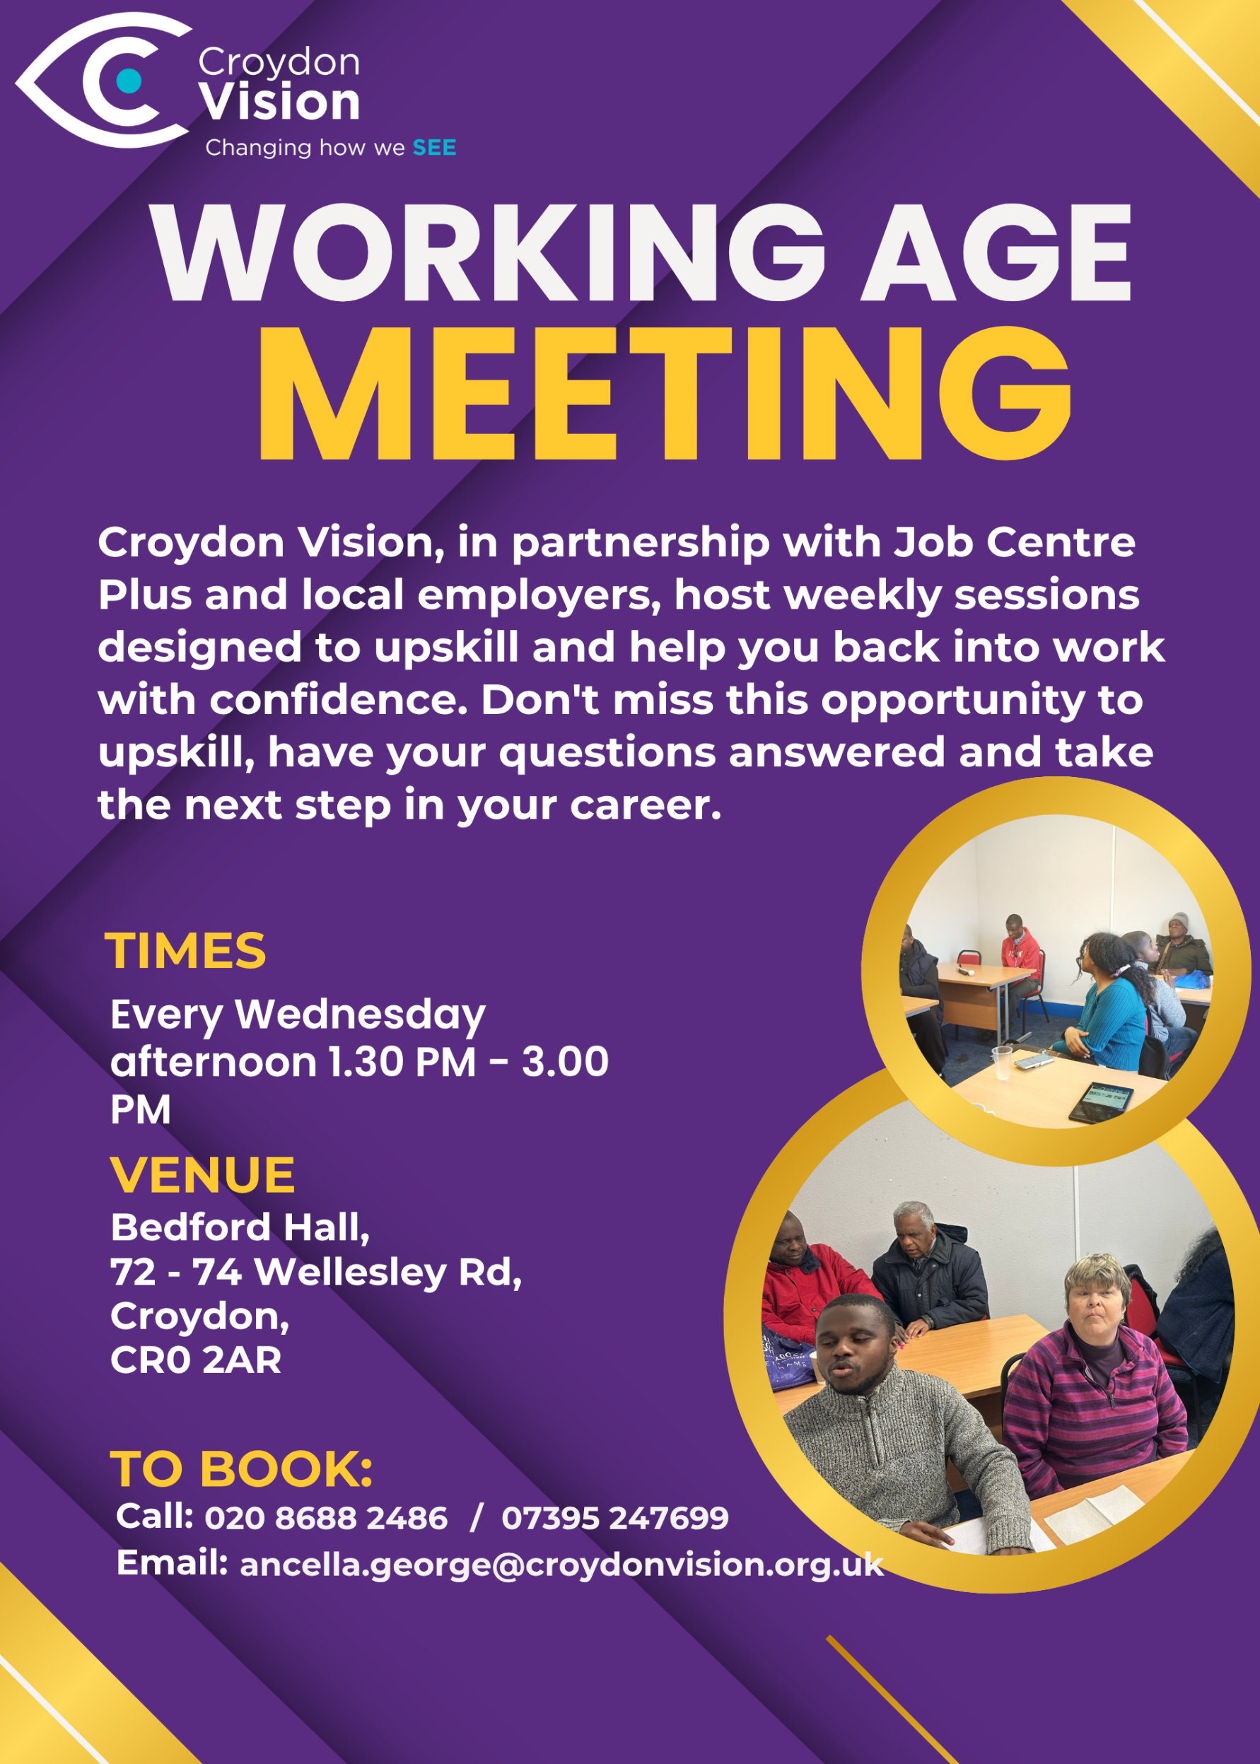
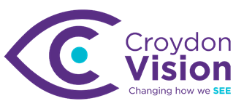

JustGiving Link:
https://www.justgiving.com/charity/croydonvisually
Weekly Meetings:
Bedford Hall 1.30pm – 3.00pm every Wednesday. Please arrive at 1.15pm for tea and coffee.

WAG Timetable:
Monday
ESL: 10.30am – 12.30pm – Bedford Lounge
Braille: 1.30pm – 3.00pm – Second Floor
Tuesday
Braille: 10.30am – 12.30pm – Second Floor
Book Club: 1.30pm – 3.00pm – Second Floor
Wednesday
Braille: 10.30am – 12.30pm – Second Floor
Craft Skills: 11.00am – 1.00pm – Lounge Area
WAG: 1.30pm – 3.00pm – Bedford Hall

Itinerary for June:
24th June | Employment Program including registration with Ingeus

JobCentre News:
- Please follow the link for apprenticeships - https://apprenticewatch.com/
- This site is for roles ranging from Labourer to Project Managers within the Construction Industry –
Search Careers - Go Construct
News from Retina UK:
Take part in a research study mapping brain development in people with early sight loss
Researchers from the Child Vision Lab at University College London (UCL) have asked us to share an opportunity to participate in a study that aims to understand how the brain adapts to changes in vision. Please note that you must be aged between 16-60 and have experienced sight loss before the age of 10 to be eligible for this study. Please find some information from the researchers below and contact them directly if you are interested in participating.
There are two parts to the study, and you are welcome to do one or both.
• Calls from home: A short phone call and a longer video call. We will talk about your background and your experience with your eye condition and go through some tasks looking at how your brain processes and stores information.
• Brain scan: A Magnetic Resonance Imaging (MRI) scan, which takes detailed pictures of your brain. You may also do a short task while in the scanner.
You will only be asked to do things you are comfortable with and you can stop at any time without giving a reason. If you are interested, our team will provide you with detailed explanations of each task. If you choose to take part in our in-person session, we will be happy to reimburse your travel costs.
The study will be running over the summer, with appointments available from the beginning of June. In-person sessions take place at the Birkbeck-UCL Centre for Neuroimaging located at 26 Bedford Way, London, WC1H 0AP. The site is in central London and well connected by public transport.
If you would like to take part, or simply want to know more about the study, we would love to hear from you. You can register your interest until the end of July, and a member of our team will then be in touch to share more information and answer any questions you may have. There is no pressure to decide right away. Email us: ioo-cvl@ucl.ac.uk

Coming Soon: For Miss La La:
Save the date for an extraordinary takeover of Croydon High Street this summer. On Sat 4 and Sun 5 July, Upswing circus company will turn the town centre into a spectacular open-air circus arena for For Miss La La - a free, two-day celebration of circus, creativity and community.

Inspired by the pioneering 19th-century aerialist Miss La La, who was of African-Prussian heritage, the event celebrates a performer who broke barriers and captivated audiences across Europe. Miss La La is immortalised in Edgar Degas' famous painting Miss La La at the Cirque Fernando, which features as part of Croydon's Art on Your Doorstep trail.

The event will bring world-class contemporary circus artists into the heart of Croydon. Visitors can enjoy spectacular performances, walkabout acts, hands-on workshops and playful activities for all ages. Presented by Upswing, the UK's pioneering contemporary circus company led by Vicki Dela Amedume MBE, For Miss La La honours her remarkable legacy while showcasing the future of contemporary circus.

More details are coming soon. For now, save the date. You can find Degas' painting Miss La La at the Cirque Fernando in Queen's Gardens as part of the Art on Your Doorstep trail until 5 July.

Sat 4 & Sun 5 July, 12pm-6pm
High Street, Croydon

Make the most of the summer holidays with the kids:

Enjoy free or discounted access to inclusive days out across the UK with an RNIB partnered Max Card – available to parents and carers of children with vision impairment. Find out more and apply by clicking the link below.

Apply now

Introducing AI Chatbots: What Are They and How Might They Help – by Kasha Doda
You may have heard family members, friends or people in the community talking about AI chatbots.
One of the best-known examples is called ChatGPT. This short introduction explains what AI chatbots are, how they may help, and what to keep in mind when using them.

What is an AI chatbot?
An AI chatbot is a digital assistant you can ask questions of. You can type a message. In some cases, you can speak to it. The chatbot then replies with an answer. You can ask it to explain something, help write a message, summarise information, give ideas, or help you prepare for a task. ChatGPT is one example of an AI chatbot. There are others too, but ChatGPT is one of the most widely known. You do not need to be technical to understand the basic idea. You ask a question, and the chatbot responds.

Part 1 on how to talk to Chat GPT will be circulated separately.

Conference:
Retina UK Annual Conference 2026
Date and Time info: 19/09/2026 from 10:00 to 16:00
Location: Birmingham
Face-to-face
To find out more and register, please visit RetinaUK.org.uk/annual-conference. Alternatively, you can call us on 01280 821334 during office hours.

Hair Care Upcoming Workshops:
We hold monthly hair and self-care workshops for blind and low vision women and young girls at Hackney Depot, East London.
If you want to feel empowered and learn more about your own hair care, as well as meet a group of amazing women, you can book a slot at our next workshop below.
If you have any issues booking, please contact hello@hairandcareproject.com
Kingston Summer Jobs Fair:
Kingston Council is delivering the Kingston Summer Jobs Fair in partnership with Kingston JCP. Residents who wish to attend can register on the day or with their Work Coach. Opportunities for careers and training are available in Education, Hospitality, Public Sector, Care, Construction, Retail, Security and Admin.

- Thursday 18th June 2026
- 10:30am – 1:30pm
- Main Guildhall, High St, KT1 1EU

Windrush Heritage Community Family Day at Lloyd Park:
Croydon Council is supporting the Windrush Heritage Community Family Day, on Sat 20 June at Lloyd Park, hosted by the Windrush Generation Legacy Association.
This free community event brings people together for a full day of celebration, marking the culture, legacy and contribution of the Windrush Generation. Enjoy live music, entertainment, food, cultural activities and plenty of family-friendly spaces across the park.
It’s a relaxed, welcoming day for all ages and backgrounds to come together, connect and celebrate shared heritage and community spirit.
The organisers are also welcoming support from volunteers, performers, traders and community groups who would like to get involved.
Sat 20 June, 11am–6pm
Lloyd Park, Croydon
Image courtesy of Windrush Generation Legacy Association.
Dr Peter’s Corner:
Part 4 of Dr Peter’s write up on ‘Understanding Your Vision’ is attached. Please feel free to share and email any questions you may have for him.

Dates for your Diary:
Vision Zone – Tuesday 23rd June at Croydon Vision
Barbecue – Friday 24th July at Croydon Vision

A: Bedford Hall, 72 - 74 Wellesley Road, Croydon, CR0 2AR
T: 020 8688 2486; Mob: 07395 247 699
E: ancella.george@croydonvision.org.uk | W: www.croydonvision.org.uk
Donate with JustGiving: https://www.justgiving.com/campaign/croydonvision

