Working Age Bulletin

Wednesday 24th June 2026

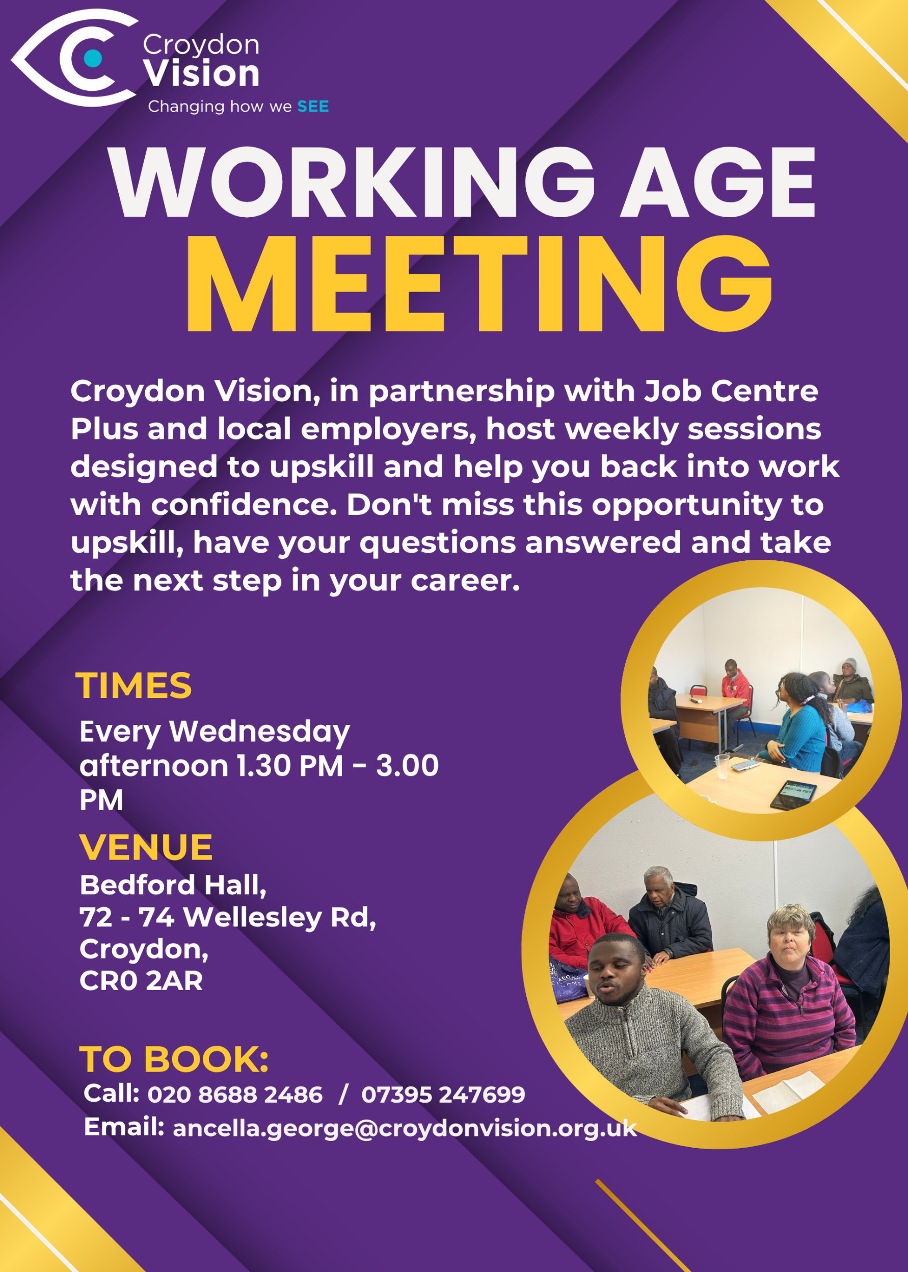
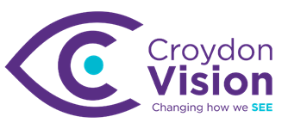

JustGiving Link:
https://www.justgiving.com/charity/croydonvisually
Weekly Meetings:
Bedford Hall 1.30pm – 3.00pm every Wednesday. Please arrive at 1.15pm for tea and coffee.

WAG Timetable:
Monday
ESL: 10.30am – 12.30pm – Bedford Lounge
Braille: 1.30pm – 3.00pm – Second Floor
Tuesday
Braille: 10.30am – 12.30pm – Second Floor
Book Club: 1.30pm – 3.00pm – Second Floor
Wednesday
Braille: 10.30am – 12.30pm – Second Floor
Craft Skills: 11.00am – 1.00pm – Lounge Area
WAG: 1.30pm – 3.00pm – Bedford Hall

Itinerary for July:
1st July | Presentation – NHS 111 Workshop
8th July | Presentation - Croydon Commitment – Ways2Work
15th July | Presentation - Sight Loss Council – Listening Month
22nd July | Presentation - The National Conversation – Ines
29th July | Engagement Talk – CMP/1-2-1 with Sasha for members wishing to be self-employed

TPT News:
Get Set Progress Internships are now live, visit https://www.pocklington.org.uk/about-us/workattpt/ for more information and how to apply.

Note: these will be updated on a regular basis.

In the Know: (Visionary)
Experience the FIFA World Cup 2026: Follow Every Match with Audio Descriptive Commentary. FIFA will be providing Audio Descriptive Commentary for all 104 matches involving all 48 participating nations as well as the opening and closing ceremonies.

The steps to access the service are as follows:
1. Download the FIFA Audio Description app from either the Apple App Store or Google Play Store.
2. Once installed, open the FIFA Audio Description app.
3. Select the match or ceremony you would like to follow.
4. Follow the simple instructions within the app to connect to the live Audio Descriptive Commentary feed.
5. Sit back, relax and enjoy the experience

NHS Talking Therapies:
This therapy can treat common anxiety conditions. If you’re struggling with obsessions and compulsions, anxiety in social situations, flashbacks of a traumatic event – or with panic attacks, obsessing about your appearance, or a phobia – being able to get on with your life again is cause for celebration.

NHS Talking Therapies treatment gives you practical skills and techniques to overcome a range of mental health conditions like obsessive compulsive disorder (OCD), social anxiety disorder, post-traumatic stress disorder (PTSD), panic disorder, body dysmorphic disorder (BDD) and phobias. The service is effective, confidential, free, and available in your chosen language, including British Sign Language (BSL), through multi-lingual therapists or interpreters. Your GP can refer you or you can refer yourself at nhs.uk/talk.
Retina UK:
Are you interested in taking part in a research study mapping brain development in people with early sight loss?
Researchers from the Child Vision Lab at University College London (UCL) have asked us to share an opportunity to participate in a study that aims to understand how the brain adapts to changes in vision. Please note that you must be aged between 16-60 and have experienced sight loss before the age of 10 to be eligible for this study. Please find some information from the researchers below and contact them directly if you are interested in participating.
There are two parts to the study, and you are welcome to do one or both.
• Calls from home: A short phone call and a longer video call. We will talk about your background and your experience with your eye condition and go through some tasks looking at how your brain processes and stores information.
• Brain scan: A Magnetic Resonance Imaging (MRI) scan, which takes detailed pictures of your brain. You may also do a short task while in the scanner.
You will only be asked to do things you are comfortable with and you can stop at any time without giving a reason. If you are interested, our team will provide you with detailed explanations of each task. If you choose to take part in our in-person session, we will be happy to reimburse your travel costs.
The study will be running over the summer, with appointments available from the beginning of June. In-person sessions take place at the Birkbeck-UCL Centre for Neuroimaging located at 26 Bedford Way, London, WC1H 0AP. The site is in central London and well connected by public transport.
If you would like to take part, or simply want to know more about the study, we would love to hear from you. You can register your interest until the end of July, and a member of our team will then be in touch to share more information and answer any questions you may have. There is no pressure to decide right away. Email us: ioo-cvl@ucl.ac.uk

Coming Soon: For Miss La La:
Save the date for an extraordinary takeover of Croydon High Street this summer. On Sat 4 and Sun 5 July, Upswing circus company will turn the town centre into a spectacular open-air circus arena for For Miss La La - a free, two-day celebration of circus, creativity and community.

Inspired by the pioneering 19th-century aerialist Miss La La, who was of African-Prussian heritage, the event celebrates a performer who broke barriers and captivated audiences across Europe. Miss La La is immortalised in Edgar Degas' famous painting Miss La La at the Cirque Fernando, which features as part of Croydon's Art on Your Doorstep trail.

The event will bring world-class contemporary circus artists into the heart of Croydon. Visitors can enjoy spectacular performances, walkabout acts, hands-on workshops and playful activities for all ages. Presented by Upswing, the UK's pioneering contemporary circus company led by Vicki Dela Amedume MBE, For Miss La La honours her remarkable legacy while showcasing the future of contemporary circus.

More details are coming soon. For now, save the date. You can find Degas' painting Miss La La at the Cirque Fernando in Queen's Gardens as part of the Art on Your Doorstep trail until 5 July.
Sat 4 & Sun 5 July, 12pm-6pm
High Street, Croydon

Conference:
Retina UK Annual Conference 2026
Date and Time info: 19/09/2026 from 10:00 to 16:00
Location: Birmingham
Face-to-face
To find out more and register, please visit RetinaUK.org.uk/annual-conference. Alternatively, you can call us on 01280 821334 during office hours.

Hair Care Upcoming Workshops:
We hold monthly hair and self-care workshops for blind and low vision women and young girls at Hackney Depot, East London.
If you want to feel empowered and learn more about your own hair care, as well as meet a group of amazing women, you can book a slot at our next workshop below.
If you have any issues booking, please contact hello@hairandcareproject.com

Dr Peter’s Corner:
Part 4 of Dr Peter’s write up on ‘Understanding Your Vision’ is attached. Please feel free to share and email any questions you may have for him.

Date for your Diary:
Barbecue – Friday 24th July at Croydon Vision

Quote of the Day:
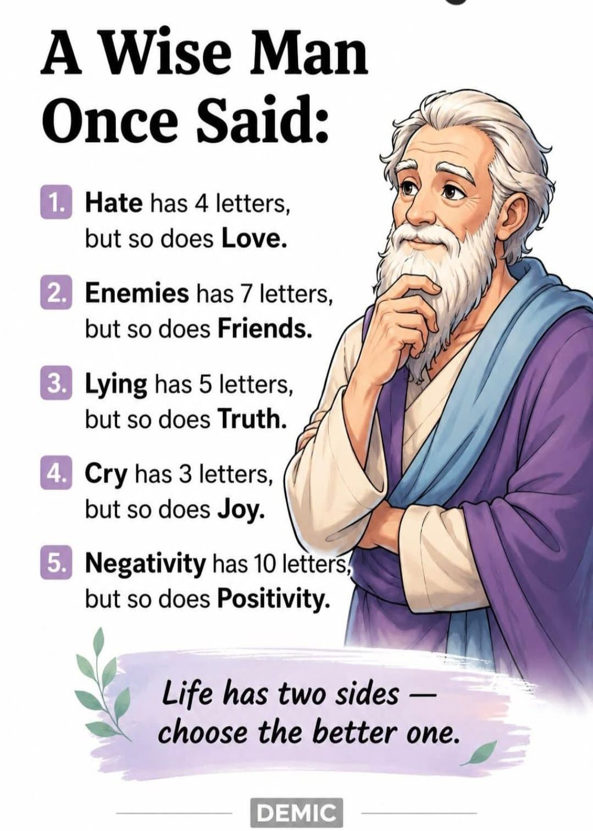

A: Bedford Hall, 72 - 74 Wellesley Road, Croydon, CR0 2AR
T: 020 8688 2486; Mob: 07395 247 699
E: ancella.george@croydonvision.org.uk | W: www.croydonvision.org.uk
Donate with JustGiving: https://www.justgiving.com/campaign/croydonvision

