Working Age Bulletin

Wednesday 08th July 2026

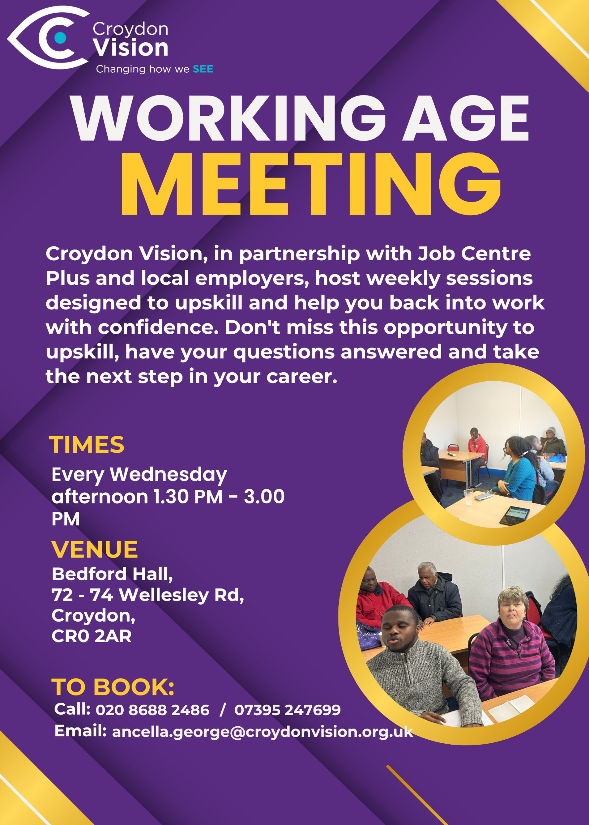


JustGiving Link:
https://www.justgiving.com/charity/croydonvisually
Weekly Meetings:
Bedford Hall 1.30pm – 3.00pm every Wednesday. Please arrive at 1.15pm for tea and coffee.

WAG Timetable:
Monday
ESL: 10.30am – 12.30pm – Bedford Lounge
Braille: 1.30pm – 3.00pm – Second Floor
Tuesday
Braille: 10.30am – 12.30pm – Second Floor
Book Club: 1.30pm – 3.00pm – Second Floor
Wednesday
Braille: 10.30am – 12.30pm – Second Floor
Craft Skills: 11.00am – 1.00pm – Lounge Area
WAG: 1.30pm – 3.00pm – Bedford Hall

Itinerary for July:
15th July | Presentation - Sight Loss Council – Listening Month
22nd July | Presentation - The National Conversation – Ines
29th July | Engagement Talk – CMP/1-2-1 with Sasha for members wishing to be self-employed

Croydon Neighbourhood Watch:
Be a good heatwave neighbour – Stay safe, Stay cool, Look out for each other!

Hot weather can affect anyone, but some people and animals are much more vulnerable during a heatwave. Small actions can make a big difference.

If you’re checking in on someone, a quick chat can help you notice early signs that they might be struggling. It doesn't need to be a big thing; you might just help them water their plants.

For pets, remember that pavements can get dangerously hot and water bowls can empty quickly in the heat.

Make sure you look after yourself too. Try to drink water regularly throughout the day, avoid being outside during the hottest hours (usually 11am–3pm), and keep homes as cool as possible by closing curtains against direct sun.

Let’s keep an eye out for each other and stay safe together.

🛼 Where the good times roll! 🎶
Looking for the perfect family night out this summer? Join us for an evening of music, skating and great vibes at our Bring Your Own Skates roller skate event!
🎧 @killerwatt_ & @djclowuk will be on the decks, bringing the freshest tunes to keep you rolling all night long.

📍 Coombe Wood School, Croydon
📅 Sunday 19 July 2026
🕖 7:00–9:00pm

👨‍👩‍👧‍👦 Family-friendly event – under 16s must be accompanied by an adult.
🎟️ Limited Early Bird tickets available! Don’t wait until they’re gone.
👉 Book now via the link in our bio and secure your spot!
Tag your skating crew and let’s make it a night to remember. 🛼✨

Instagram: https://www.instagram.com/skateinn_london
Website: https://skateinn.co.uk/all-events/roller-disco/
Booking link: https://www.eventbrite.co.uk/e/skate-inn-roller-disco-tickets-1991931292116

TPT News:
Get Set Progress Internships are now live, visit https://www.pocklington.org.uk/about-us/workattpt/ for more information and how to apply.

Extant is Hiring:
The Operations Lead:
Opportunity🚨Extant are hiring for an Operations Lead! Extant has made a commitment to working towards all its internal roles being held by VI people in 2033. The Operations Lead will begin this process.
Applications close on 7th August, 12 noon
Apply here: https://extant.org.uk/operations-lead

The Extant Hive:
Opportunity🚨Extant are hiring for The Extant Hive with 4 paid new roles available! Extant are transforming as part of their 30th anniversary with The Extant Hive, a new visually impaired leadership team.
Applications close on 25th August, 12 noon
Apply here: https://extant.org.uk/the-extant-hive

Free outdoor cinema mornings in Croydon this July:
Croydon BID is teaming up with David Lean Cinema for two free outdoor film mornings as part of Centre Court Croydon – a pop-up viewing space at Caithness Walk, East Croydon where people can watch the Wimbledon Championships on a big screen on Sunday 12 July.

Alongside the tennis, there are also two family film mornings taking place on Sat 4 and Sat 11 July.

On Sat 11 July, it’s Lilo & Stitch, about a young girl and a mischievous alien who form an unlikely friendship.

With the warmer weather, it’s a chance to head into town, settle in and watch a film outside in the middle of everything. Beanbags and deckchairs will be available on a first come, first served basis.

TAO Café and Heavenly Desserts will be on site if you want a drink or something to eat while you’re there.

Sat 11 July, 10am-12pm
Caithness Walk, East Croydon
No booking required

NHS Talking Therapies:
This therapy can treat common anxiety conditions. If you’re struggling with obsessions and compulsions, anxiety in social situations, flashbacks of a traumatic event – or with panic attacks, obsessing about your appearance, or a phobia – being able to get on with your life again is cause for celebration.

NHS Talking Therapies treatment gives you practical skills and techniques to overcome a range of mental health conditions like obsessive compulsive disorder (OCD), social anxiety disorder, post-traumatic stress disorder (PTSD), panic disorder, body dysmorphic disorder (BDD) and phobias. The service is effective, confidential, free, and available in your chosen language, including British Sign Language (BSL), through multi-lingual therapists or interpreters. Your GP can refer you or you can refer yourself at nhs.uk/talk.

Dr Peter’s Corner:
Attached in colour, is Dr Peter’s part 5 write up on ‘Understanding Your Vision’.

Dates for your Diary:
Barbecue – Friday 24th July at Croydon Vision (Poster attached)
Loss and Legacy Workshops – 2nd, 9th, 16th September (Poster attached)

Quote of the Day:
"The only way to do great work is to love what you do." — Steve Jobs — Passion fuels excellence and perseverance (Burning for Success)

A: Bedford Hall, 72 - 74 Wellesley Road, Croydon, CR0 2AR
T: 020 8688 2486; Mob: 07395 247 699
E: ancella.george@croydonvision.org.uk | W: www.croydonvision.org.uk
Donate with JustGiving: https://www.justgiving.com/campaign/croydonvision



