Working Age Bulletin

Wednesday 12th August 2026

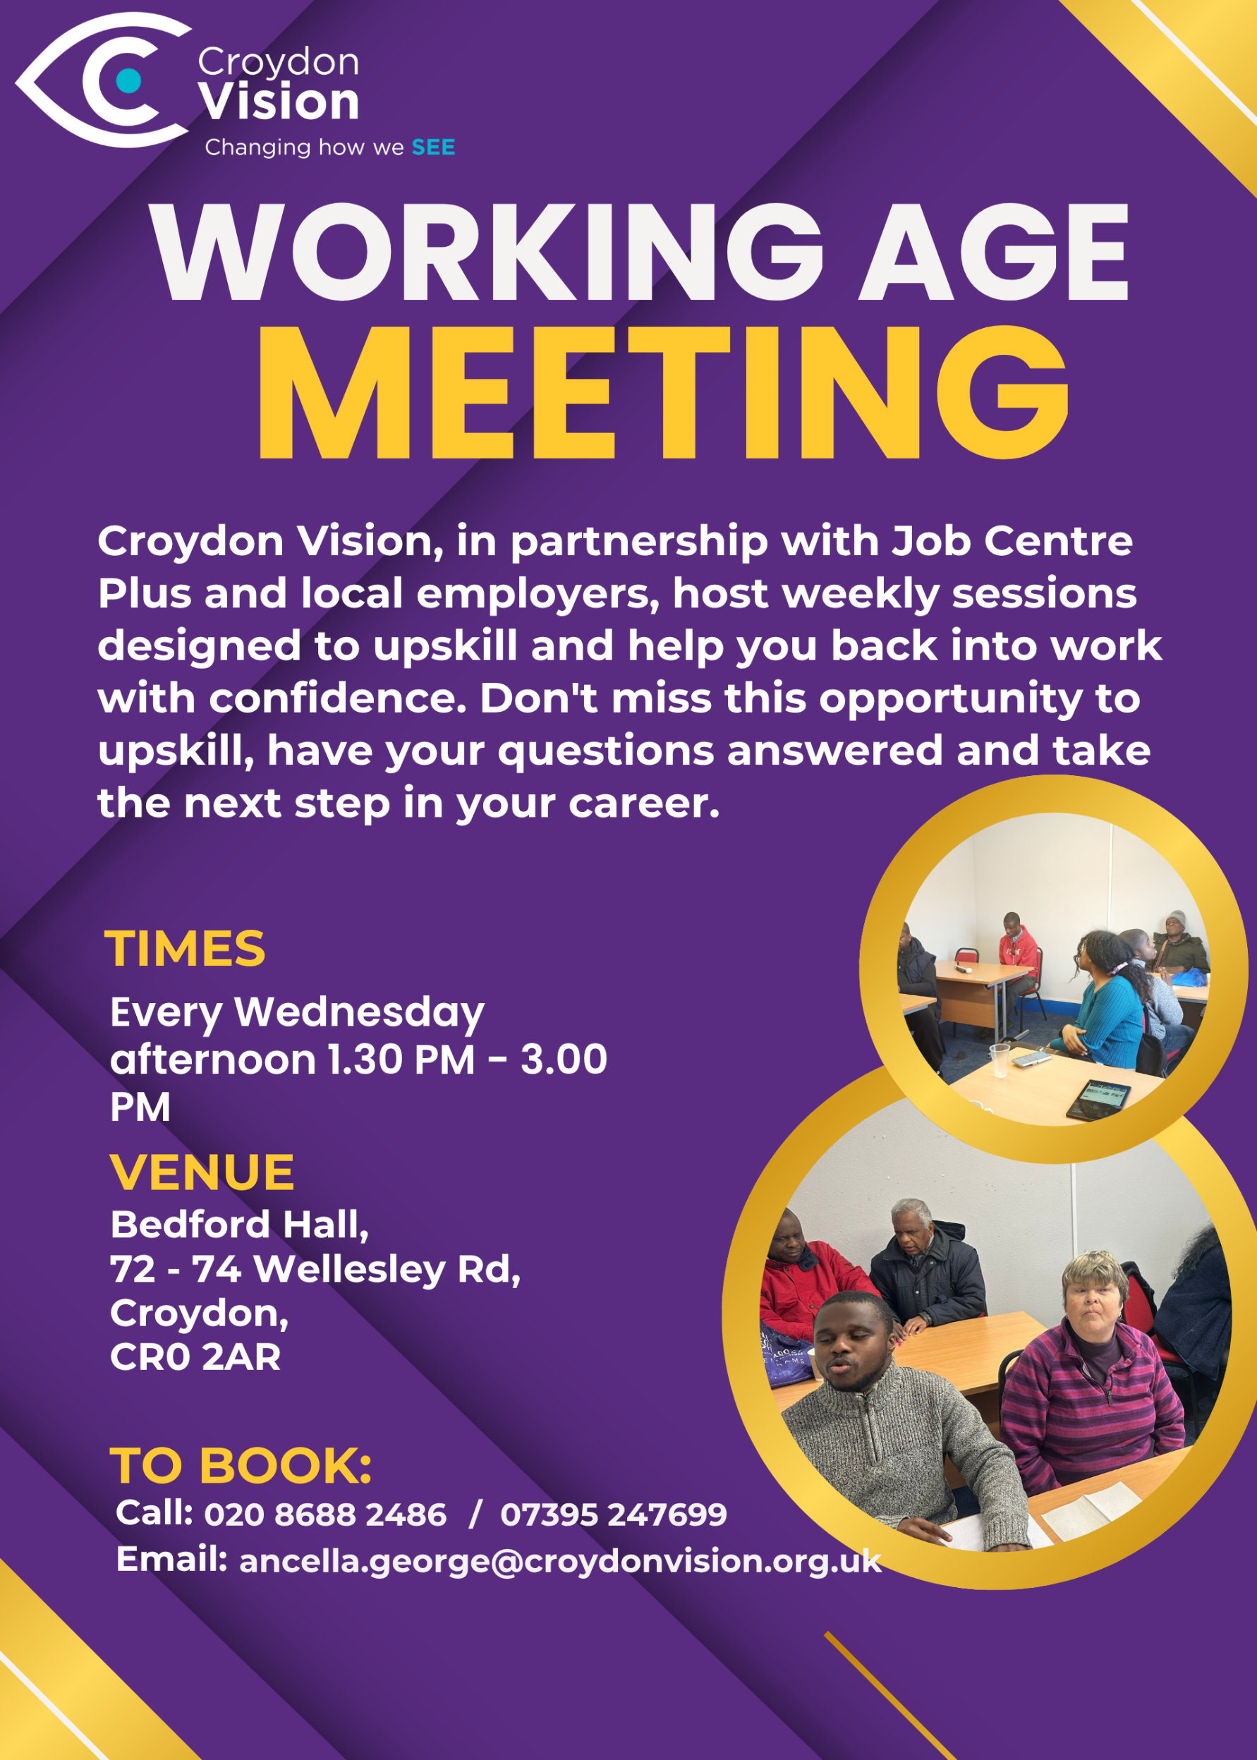
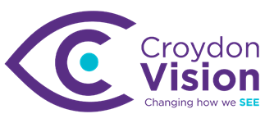

JustGiving Link:
https://www.justgiving.com/charity/croydonvisually
Weekly Meetings:
Bedford Hall 1.30pm – 3.00pm every Wednesday. Please arrive at 1.15pm for tea and coffee.

WAG Timetable:
Monday
ESL: 10.30am – 12.30pm – Bedford Lounge
Braille: 1.30pm – 3.00pm – Second Floor
Tuesday
Braille: 10.30am – 12.30pm – Second Floor
Book Club: 1.30pm – 3.00pm – Second Floor
Wednesday
Braille: 10.30am – 12.30pm – Second Floor
Craft Skills: 11.00am – 1.00pm – Art Room
WAG: 1.30pm – 3.00pm – Bedford Hall

Itinerary for August:
12th August | In-House workshop (IT) – Daniel brainstorming
19th August | Social and Creative skills exhibition
26th August | NO REGULAR MEETING – Visit to Music Relief Foundation
Note from our CEO:
With today's eclipse attracting plenty of attention, I thought it was worth a quick reminder from a charity that knows a thing or two about looking after our eyes!
While eclipses are fascinating, it's important not to look directly at the sun at any point without proper eclipse viewing glasses. Ordinary sunglasses won't protect your eyes, and staring at the sun can cause permanent damage, often without any immediate pain or warning signs.
If you're planning to take a look:
🌞 Use certified eclipse viewing glasses
🔭 Never look through binoculars, telescopes, or cameras unless they have specialist solar filters attached
💻 Consider watching online coverage instead
📄 Or try a simple pinhole projector for a safe indirect view
As champions of eye health and sight loss awareness, let's make sure we're practising what we preach today!
For anyone wanting to give the pinhole projector a go, here's a quick guide. This is what I'll be trying with the kids later!
How to make a simple pinhole projector:
- Take a piece of card or stiff paper.
- Use a pin or drawing pin to make a small hole in the middle.
- Stand with your back to the sun.
- Hold the card up so sunlight passes through the hole.
- Project the light onto the ground, a wall, or another piece of white paper held behind it.
- You'll see a small image of the sun, and as the eclipse progresses, you'll notice part of it appears missing.
It's a simple, safe, and surprisingly effective way to experience the eclipse without risking your eyesight.
The next one with this coverage is predicted for 2090 so enjoy the celestial spectacle and keep those eyes safe. 😊
IT Training:
WAG IT training will take place from the middle of September to end October. Our brainstorming this afternoon with Daniel identified several areas in which upskilling is needed. A full timetable will be circulated by end August. In the meantime, it was agreed that group training sessions will be on a Thursday comprising of 2hr slots morning and afternoon. Individual sessions will be agreed with each member to fit around Daniel, Alexej and Darin’s schedule. I will circulate separately the topics to be covered.

Get 15% off tickets for a summer circus spectacular coming to South Norwood
The Revel Puck Circus brings its Big Top to Croydon for one week only with A Glimmer Daze Gambit. This joyful, family-friendly contemporary circus show is packed with jaw-dropping acrobatics, aerial performance, clowning and features a brilliant soundtrack. All performances are relaxed, so you’re welcome to move, take breaks and re-enter if needed. Catch the show at Norwood Recreation Ground from Thursday 20 to Sunday 23 August and get great deals on tickets. Get 15% off 20–23 August with code SUMMER15.

Tickets: £10 - £33.04
Thurs 20 – Sun 30 August
South Norwood Recreation Ground, Tennison Road SE25 6TG
BOOK HERE

TRAM August Disruption:
We are amending tram services this August due to essential engineering works to improve the tramway. The changes are as listed below.

Thursday 6 August to Sunday 30 August
There will be no service between Reeves Corner and East Croydon.

Trams will run between Wimbledon and Reeves Corner, and between East Croydon and New Addington, Beckenham Junction and Elmers End. Please be advised that the Elmers End service will start and finish earlier than usual. There will be no service between Arena and Elmers End at these times:
• Before 07:00 and after 19:30 on Weekdays
• Before 08:00 and after 18:45 on Saturdays
• No service to/from Elmers End on Sundays
On the evenings of Sunday 16 and Thursday 20 August, there will be additional service disruption from 20:00 until the start of service the following day.

On Sunday 16 August:
• No service between Therapia Lane and Reeves Corner after 22:00
• No service between East Croydon to Beckenham Junction, and between East Croydon and New Addington after 22:30
• No service to/from Elmers End all day.

On Thursday 20 August:
• No service between Therapia Lane and Reeves Corner, after 22:00

Please check before you travel, allow more time for your journey and where possible consider using local buses, walking, or cycling. Our Journey Planner and TfL Go app can help you plan your journey as required.

We are sorry for the disruption this may cause.

Peppa Pig Live is back at Fairfield Halls:
Get ready for plenty of giggles, songs and muddy puddles as Peppa Pig's Big Family Show comes to Fairfield Halls this August.
Join Peppa, George, Mummy Pig, Daddy Pig and brand-new baby Evie for an oinktastic family adventure packed with music, surprises and plenty of fun along the way.
Perfect for little ones, it's a brilliant first theatre experience, bringing the much-loved TV characters to life on stage in a colourful show designed for young audiences.
With more than 2.5 million people having enjoyed Peppa's live adventures over the years, this latest production promises another heartwarming day out for families.
Fri 21 & Sat 22 Aug
Fairfield Ashcroft Theatre, Fairfield Halls
Image: Peppa Pig’s Big Family Show. Credit: Mark Senior
BOOK YOUR TICKETS

Sight Loss Council – Tram Awareness
Alt text
Graphic for a Southwest London SLC's event. The SLC logo appears at the top of a white background, followed by large text reading "Try a tram at Wimbledon Station". Below, the date "22nd September" and time "11am–2pm" are displayed alongside a turquoise button labelled "Book on our website". The lower half shows a top-down photograph of a person standing behind a yellow line next to tactile paving on a tram platform. A curved white border separates the event information from the photograph.

Image description: A social media graphic promoting Southwest London Sight Loss Council's "Try a tram at Wimbledon Station" event on 22 September from 11am–2pm. The image features a person standing on a station platform behind a yellow safety line, with tactile paving visible along the platform edge.

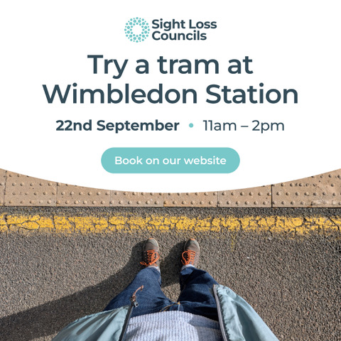

Bucket and spade season in Croydon:
No need to head for the coast this summer - Costa Del Croydon is returning to Centrale with a rooftop beach packed with free family-friendly fun throughout August.

There will be giant sandpits and splash zones, family workshops, games, fairground rides and street food - plenty to keep little ones entertained during the school holidays. ‘Community Tuesdays’ will also celebrate local talent, creativity and community groups from across the borough.

With free entry and activities running throughout the month, it's an easy way to enjoy a summer day out closer to home. And should the weather take a turn, selected activities will move indoors to dedicated spaces within the centre, ensuring your day out can continue whatever the forecast.

When the sun goes down, the new adults-only Beach Club takes over every Thursday, bringing rooftop DJs, cocktails, street food and live entertainment to Croydon’s summer social scene.
Fri 7- Sat 31 August - Free entry / Family sessions daily
Centrale Rooftop Car Park (Level 3A), Croydon

Dr Peter’s Corner:
Dr Peter’s part 7 write up on ‘Understanding Your Vision’ is attached.

Today's quote is by Winston Churchill:
"Success is not final, failure is not fatal: it is the courage to continue that counts."

A: Bedford Hall, 72 - 74 Wellesley Road, Croydon, CR0 2AR
T: 020 8688 2486; Mob: 07395 247 699
E: ancella.george@croydonvision.org.uk | W: www.croydonvision.org.uk
Donate with JustGiving: https://www.justgiving.com/campaign/croydonvision

