Children & Young People’s September 2026 Bulletin
💙 Welcome back!
We hope everyone has had a wonderful summer and is looking forward to the new term.
What a summer we have had at Croydon Vision! It has been fantastic to spend time with so many of our children, young people, parents and carers over the holidays. There has been lots of fun, laughter, new experiences and opportunities to build friendships, confidence and independence☀️ WHAT A SUMMER!

Our summer programme was packed with activities and adventures, including Chessington World of Adventures, Margate seaside trip, cinema, pottery, arts, crafts and games, alongside our other summer activities.
It was wonderful to see everyone getting involved, trying new things and simply enjoying being together.
A huge THANK YOU to all the parents and carers who joined us on activities and helped along the way. Your support really does make a difference.
It was a pleasure to spend such positive and enjoyable time together as a Croydon Vision community.

📸 SUMMER MEMORIES
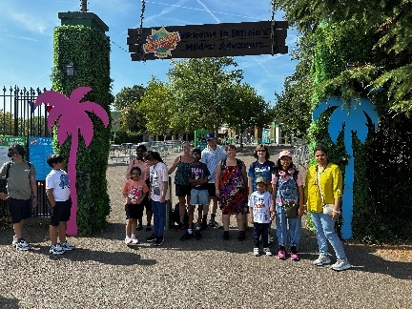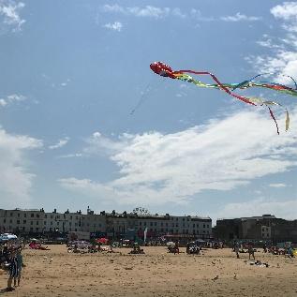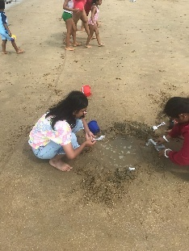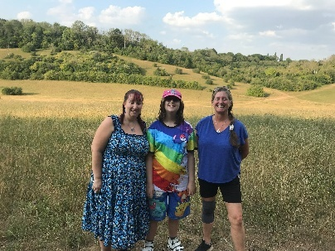
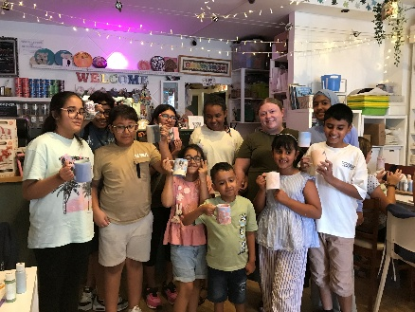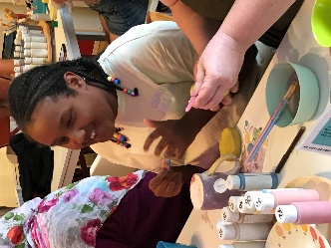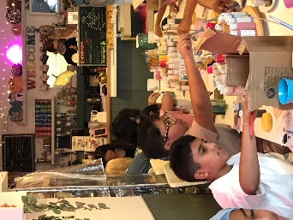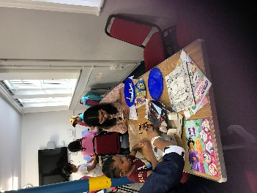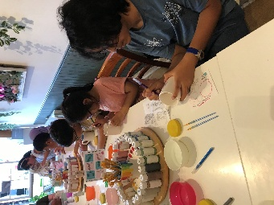
Chessington • Margate • Cinema • Pottery • Arts, Crafts & Games • Summer Fun

🎉 OUR BIGGEST SUMMER BBQ EVER!
What a fantastic day!
This year’s Croydon Vision Summer BBQ was our biggest ever, with a record-breaking 120 attendees.
We were delighted that so many of our children, young people and families could be part of such a successful and memorable day.
There was a wonderful community atmosphere, with opportunities to catch up with old friends, make new ones, enjoy activities, food and entertainment and, most importantly, have fun together.
Thank you to everyone who attended, volunteered, performed, helped with activities or supported the day.
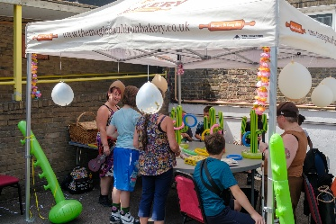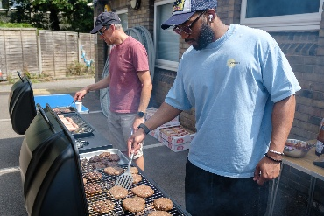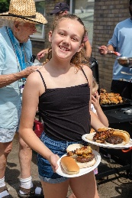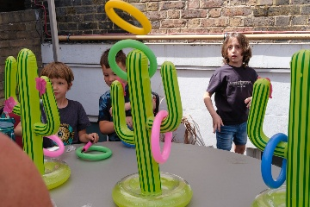

💬 WE NEED YOUR FEEDBACK!
If you or your child took part in our summer activities, please complete the evaluation form that has been sent out.
Your feedback is extremely important to us.
It helps us understand:

- What you enjoyed
- What worked well
- What difference the activities make?
- What we could improve
- What activities would you like in the future

Your feedback also helps us demonstrate the impact of our Children & Young People’s Service to our funders and helps us continue developing opportunities for children and young people.
Thank you to everyone who has already completed an evaluation!

👨‍🍳 CROYDON COOKS YOUTH AWARD
Could YOU be part of Team Croydon Vision?
We are excited to be taking part in the Croydon Cooks Youth Award 2026 and we would love more young people to get involved!
The award is a fantastic opportunity to develop cooking skills, confidence, creativity and teamwork while having plenty of fun along the way.

🍲 Team Planning & Cooking Dates
📅 Friday 11 September
📅 Saturday 12 September
These sessions will give our team the opportunity to meet, share ideas, plan and get cooking!
If you have already signed up, please save these dates.
More information will follow shortly.
Interested in joining the Croydon Vision team? Please get in touch.

🗓️ CROYDON VISION CYP – DATES FOR YOUR DIARY

🌟 Young People’s Team
Mondays | 5pm–8pm
Come along, meet other young people, share your ideas and help shape the future of Croydon Vision’s Children & Young People’s Service.
September: 7th & 14th
October: 5th & 19th
November: 2nd & 16th
December: 7th & 14th

🎮 Friday Open Sessions
A relaxed space to meet others, socialise and take part in different activities.
5pm to 7pm
September: 11th & 18th
October: 9th & 30th
November: 13th & 27th
December: 11th & 18th
Activity information and times to follow.

🎨 Saturday Open Sessions
10.30am–1.30pm
September: 12th
October: 10th
November: 21st
December: 19th
Activities will vary, so look out for further information about what’s happening at each session.

💡 WHAT WOULD YOU LIKE TO DO?
This is YOUR programme and we want YOUR ideas!
Is there somewhere you have always wanted to visit?
Would you like to try a new sport, creative activity, cooking, music, gaming, theatre or something completely different?
Perhaps there is something you would like us to organise during the October half-term or Christmas holidays? Please send us your ideas. We want our programme to reflect what you want to do.
All suggestions are welcome!

📷 RNIB – SEEN
During September, RNIB is hosting Seen, a photography exhibition featuring 22 portraits and stories of blind and partially sighted people.
The exhibition celebrates individuals and their stories while challenging perceptions around sight loss. It will be hosted at RNIB’s Grimaldi Building and online.
Find out about RNIB Seen https://www.rnib.org.uk/campaign-with-us/join-us-this-september-for-the-launch-of-seen/welcome-to-seen/

🏡 WHAT’S ON IN CROYDON?
Croydon Family Hubs
Croydon Family Hubs offer activities, information and support for families, children and young people. The service supports families with young people up to 19 years, or 25 where a young person has SEND.
September timetables and information about activities are available online.
Croydon Family Hubs https://www.croydon.gov.uk/children-young-people-and-families/family-hubs

♿ Croydon Local Offer
Don’t forget the Croydon Local Offer, where children, young people, parents and carers can find information about SEND services, activities, leisure opportunities, education, health, wellbeing, short breaks and other local support.
Croydon SEND Local Offer https://www.croydon.gov.uk/children-young-people-and-families/special-educational-needs-and-disability-support/local-offer-special-education-and-disability-support-directory

💳 Croydon Disability Register & Access Card
Eligible Croydon children and young people can join the Disability Register and receive a free Access Card. The scheme can help communicate access requirements and may provide concessions such as companion tickets and discounts at participating venues.
Find out about Croydon’s Disability Register and Access Card https://www.croydon.gov.uk/libraries-leisure-and-culture/children-and-young-people/croydon-disability-register-and-access-card

WOW: World of Work
WOW: World of Work on Thursday 17 September at Weatherill House.
We’re bringing young people together with employers and professionals for practical, honest conversations about careers and the world of work.
Joining us will be BAFTA and Emmy Award-winning producer-director Jyoti Mehta and broadcaster and former UK Small Business Commissioner Liz Barclay, alongside other employers and professionals. We’re simply asking employers to share their experiences, answer questions and help young people better understand the opportunities available to them.
📅 Thursday 17 September 2026
⏰ 4pm to 7pm
📍 Weatherill House, Croydon
Reserve your place: https://www.eventbrite.co.uk/e/wow-the-world-of-work-climbing-up-the-ladder-tickets-1994002467056

🌿 HEALTH & WELLBEING CORNER

September – Back into a Healthy Routine
September can bring lots of changes – returning to school or college, starting new activities and getting back into routines after the summer holidays. Here are a few simple ways to look after your wellbeing this month.

😴 Get Back into a Sleep Routine
After the summer, bedtime can sometimes be a little later! Try gradually getting back to regular sleep and wake-up times. A good night’s sleep can help with concentration, mood and energy.

🧠 Look After Your Mind
Starting a new school year, college course or activity can feel exciting – but sometimes a little worrying too.
Remember: it’s okay to talk about how you’re feeling. Speak to someone you trust if something is worrying you.

🚶 Get Moving
Movement is good for both our physical and mental wellbeing. It doesn’t have to mean going to the gym!
Try:
- going for a walk
- dancing to your favorite music
- swimming
- adapted or VI sport
- stretching
- getting outside with family or friends

💧 Water, Water, Water!

Remember to keep hydrated throughout the day. Carrying a reusable water bottle to school, college or activities can make it easier to remember to drink regularly.

🥗 Fuel Your Day
Regular meals and snacks can help maintain your energy throughout a busy day.
Why not try preparing a healthy snack or learning to make something new? Our Croydon Cooks team will certainly be practicing their kitchen skills this month!

📱 Take a Screen Break
Phones, gaming and social media are part of everyday life, but remember to give yourself a break.
Try putting your phone down for a while and doing something different – listen to music, get outside, cook, create something, exercise or simply have a chat with someone.

🤝 Stay Connected
Spending time with other people can be great for our wellbeing.
Croydon Vision’s CYP activities are a chance to meet people, make friends, have fun and try something new.
If you haven’t joined us before, September could be the perfect time to give one of our sessions a try!

💜 SEPTEMBER WELLBEING CHALLENGE
Try to do ONE thing each week that makes you feel good!
🌳 Spend some time outdoors
📵 Have some screen-free time
🥗 Make or try something healthy
🎵 Listen to your favorite music
👋 Talk to or meet up with a friend
😊 Do something just because you enjoy it
Small things can make a big difference to our wellbeing.

📣 KEEP IN TOUCH
We have lots planned for the rest of 2026 and we want our children, young people and families to be involved in shaping what comes next.
Look out for further information about our Friday and Saturday activities, Young People’s Team sessions, Croydon Cooks and October half-term activities.
Please continue to share your ideas, suggestions and feedback with us.

Together we can make Croydon Vision’s CYP programme even better!
Angela Ben-Arie
Children & Young People’s Engagement Coordinator
📧angela.b.arie@croydonvision.org.uk
📱 07742 410262
Supporting children and young people to build confidence, independence, friendships and have their voices heard.

