Working Age Bulletin

Wednesday 2nd September 2026

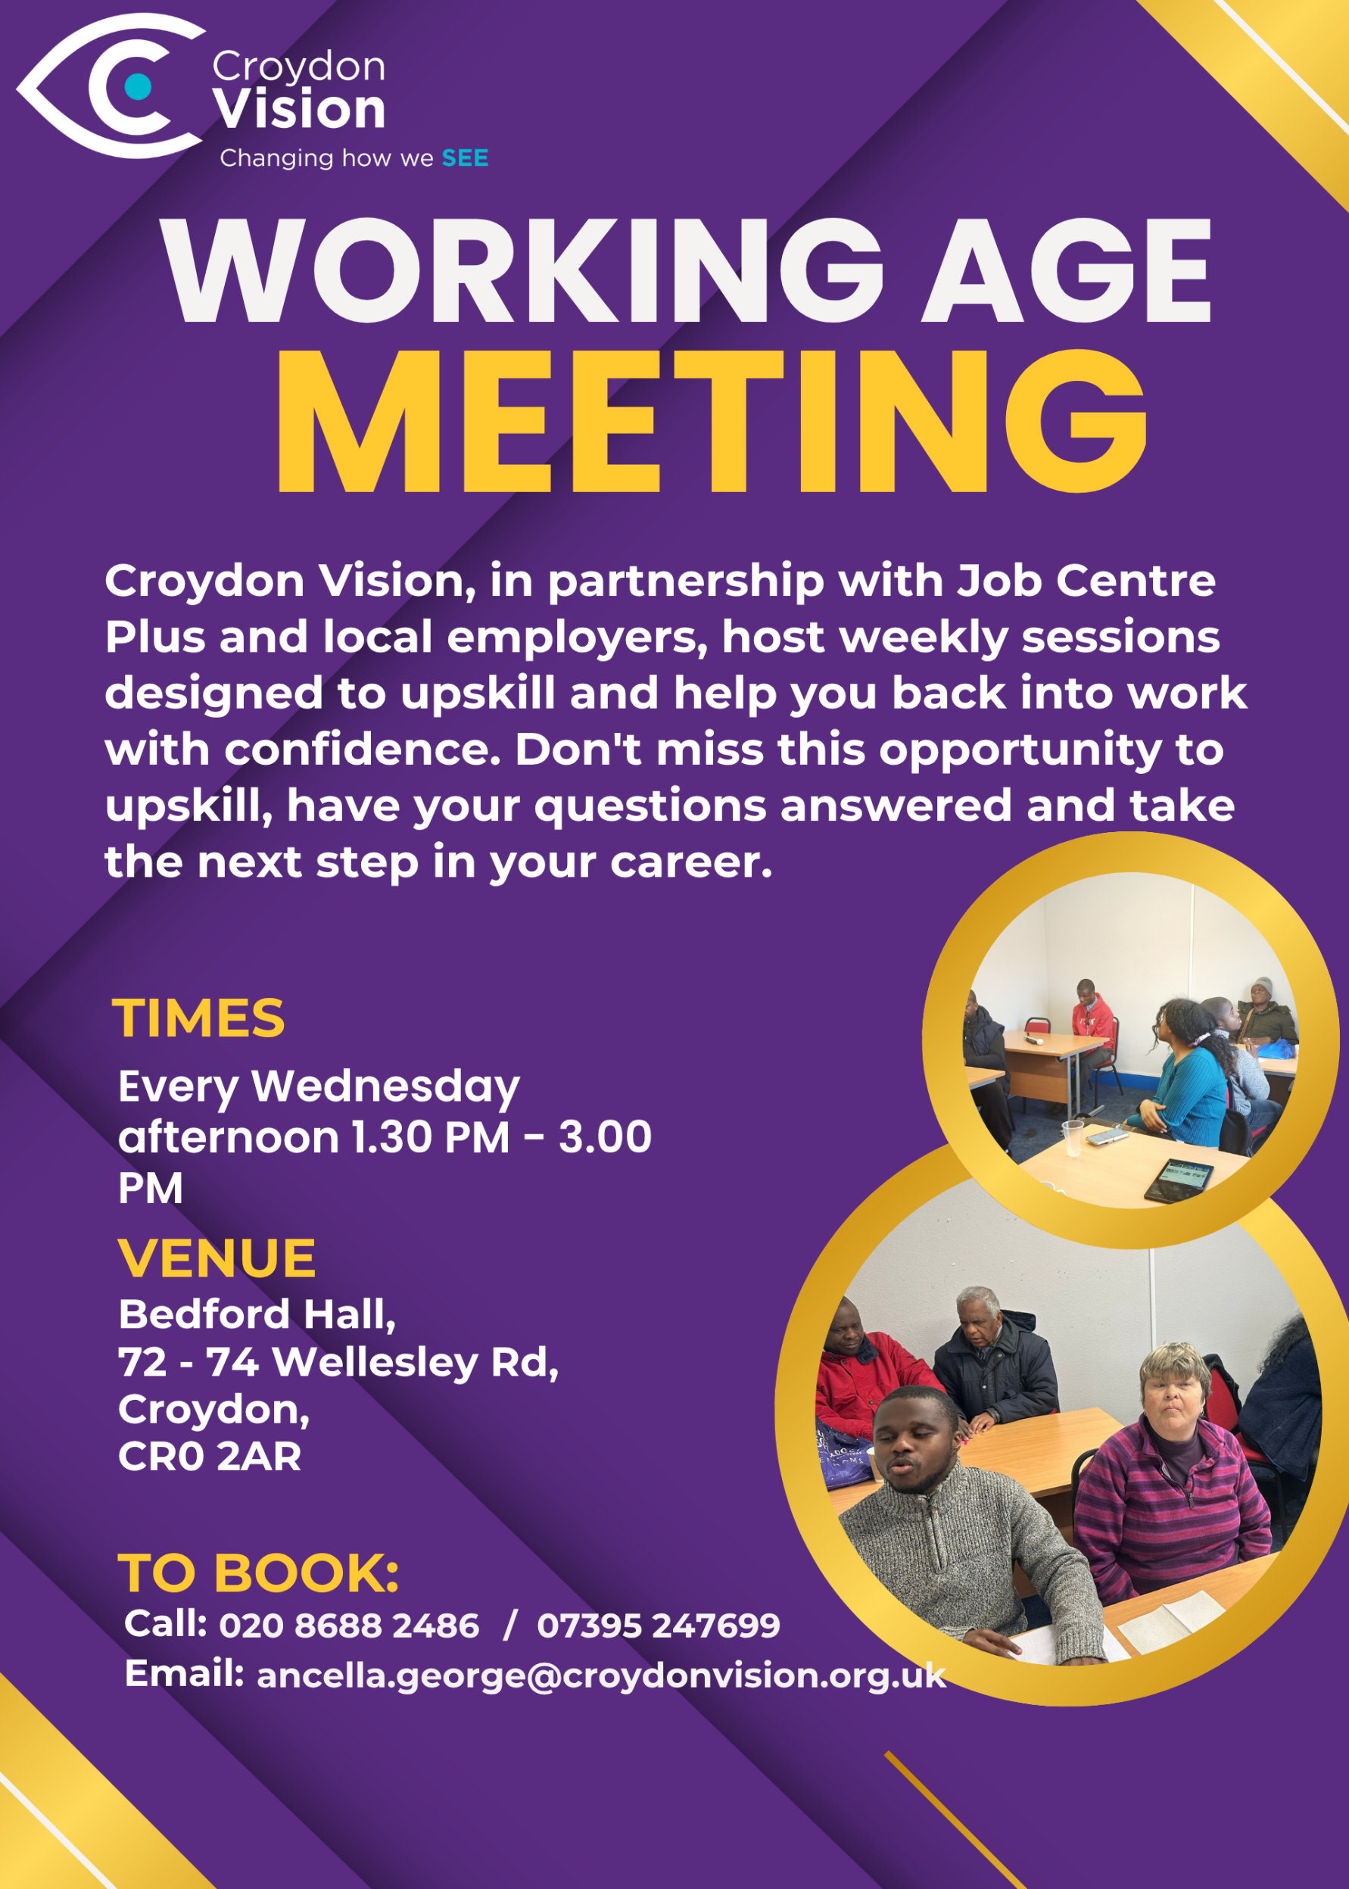
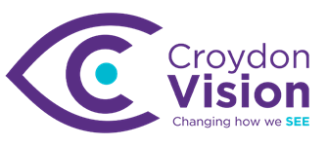

JustGiving Link:
https://www.justgiving.com/charity/croydonvisually
Weekly Meetings:
Bedford Hall 1.30pm – 3.00pm every Wednesday. Please arrive at 1.15pm for tea and coffee.

WAG Timetable:
Monday
ESL: 10.30am – 12.30pm – Bedford Lounge
Braille: 1.30pm – 3.00pm – Second Floor
Tuesday
Braille: 10.30am – 12.30pm – Second Floor
Knitting: 12.00 – 2.00pm - Second Floor
Book Club: 1.30pm – 3.00pm – Second Floor
Wednesday
Braille: 10.30am – 12.30pm – Second Floor
Craft Skills: 11.00am – 1.00pm – Art Room
WAG: 1.30pm – 3.00pm – Bedford Hall

Itinerary for September:
2nd September | AI Ethics Workshop – AVR (Part 1)
9th September | AI Ethics Workshop – AVR (Part 2)
16th September | Cyber Security Workshop – What to know
23rd September | Pension Workshop – Money Management
Job Opportunities:
Work with us!
Passionate about the power of creativity to improve health and wellbeing? Croydon Council is recruiting for two exciting roles working across arts, culture, health and community.

Creative Health Development Officer:
Support and develop creative health programmes in Croydon, helping local artists and community organisations deliver projects that improve health and wellbeing.
Deadline: Thurs 3 September, 11.55pm
APPLY HERE

Be My Eyes – News:
We are thrilled to announce our official partnership with NatWest, the first-ever bank to use our Customer Accessibility Suite on the Be My Eyes platform!

Now NatWest customers who are blind or have low vision will be able to call NatWest service agents directly from inside the Be My Eyes app and get trusted sighted assistance with NatWest banking services.

The launch itself will be a carefully phased rollout, starting with a ‘closed pilot’ period running for two weeks from September 14th. Through this initial pilot period, some selected NatWest customers will be able to test out real examples of using Be My Eyes to connect to trained NatWest staff for any assistance that they might need.

Would you like to be one of the first?
NatWest and Be My Eyes would love for you to try it out by joining the first rollout phase. You will be able to use it whenever you need quick visual help with tasks like reading card machines or ATMs, sorting out your cards, going through NatWest mail, or anything else where an extra pair of eyes comes in handy. Feel free to test it on any other everyday banking scenarios you run into, too!

Register your interest
If you are already a NatWest customer and would like to participate in the pilot, please send an email to andy.lane@bemyeyes.com to learn more. But do be quick, we’ll need to close the window for the first phase soon.
The Be My Eyes Team

IT Training at Croydon Vision:
WAG IT training will take place from the end of September to mid-November and weekly thereafter on a 1-2-1 basis. A full timetable will be circulated by mid-September. In the meantime, it was agreed that group training sessions will be on a Thursday comprising of 2hr slots morning and afternoon. Individual sessions will be agreed with each member to fit around Daniel, Alexej and Darin’s schedule. Alexej will set the scene during our workshops in September.

Croydon News:
Something big to look forward to in Croydon this September.

As part of this year’s Open House Festival, we are bringing a weekend of design-inspired creativity and play to The Queen’s Gardens with Build / Play / Shape!

Kickstarting the festival on Sat 12 and Sun 13 September, this free weekend invites curious minds of all ages to explore the shape of our borough.

Construct a giant cardboard Croydon skyline, transform iconic local buildings into futuristic spacecraft, and dive into an adventure playground featuring den building and a mud kitchen!

There’s also an exhibition of Croydon photography inside a delightful retro caravan and creative quests to complete at our Curiosity Rover.

Sight Loss Council – Tram Awareness
Alt text
Graphic for a Southwest London SLC's event. The SLC logo appears at the top of a white background, followed by large text reading "Try a tram at Wimbledon Station". Below, the date "22nd September" and time "11am–2pm" are displayed alongside a turquoise button labelled "Book on our website". The lower half shows a top-down photograph of a person standing behind a yellow line next to tactile paving on a tram platform. A curved white border separates the event information from the photograph.

Image description: A social media graphic promoting Southwest London Sight Loss Council's "Try a tram at Wimbledon Station" event on 22 September from 11am–2pm. The image features a person standing on a station platform behind a yellow safety line, with tactile paving visible along the platform edge.

Dr Peter’s Corner:
Dr Peter’s part 8 write up on ‘Understanding Your Vision’ is attached.

Today's quote:
Consistency wins: Showing up every day is more powerful than rushing and quitting.

A: Bedford Hall, 72 - 74 Wellesley Road, Croydon, CR0 2AR
T: 020 8688 2486; Mob: 07395 247 699
E: ancella.george@croydonvision.org.uk | W: www.croydonvision.org.uk
Donate with JustGiving: https://www.justgiving.com/campaign/croydonvision

