Working Age Bulletin

Wednesday 16th September 2026

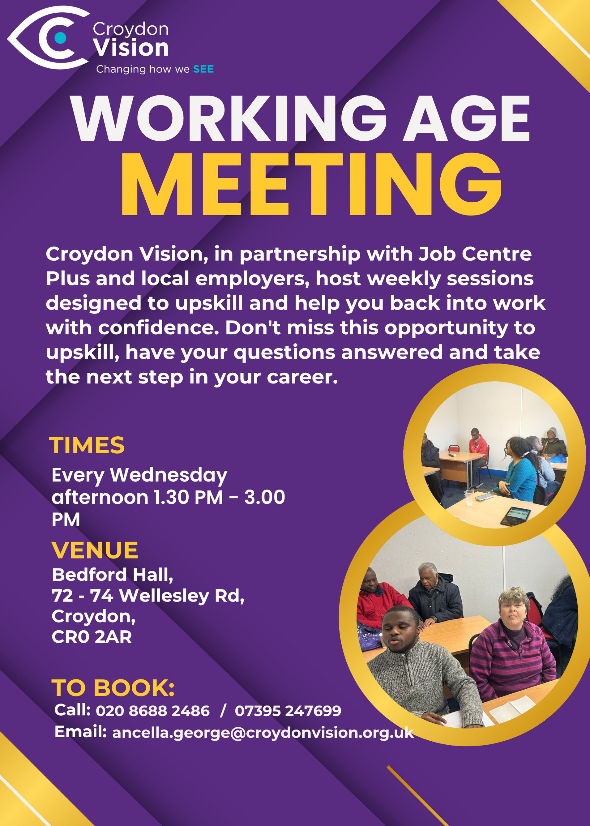
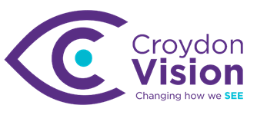

JustGiving Link:
https://www.justgiving.com/charity/croydonvisually

Weekly Meetings:
Bedford Hall 1.30pm – 3.00pm every Wednesday. Please arrive at 1.15pm for tea and coffee.

WAG Timetable:
Monday
ESL: 10.30am – 12.30pm – Bedford Lounge
Braille: 1.30pm – 3.00pm – Second Floor
Tuesday
Braille: 10.30am – 12.30pm – Second Floor
Knitting: 12.00 – 3.00pm – Lounge
Book Club: 1.30pm – 3.00pm – Second Floor
Wednesday
Braille: 10.30am – 12.30pm – Second Floor
Craft Skills: 11.00am – 1.00pm – Art Room
WAG: 1.30pm – 3.00pm – Bedford Hall

Itinerary for September:
16th September | Cyber Security Workshop – Overview ‘What to know’
23rd September | Pension Workshop – Money Management
30th September | Hosting Hugh Sorril, CEO Coventry Vision Hub - Workshop by Croydon Commitment
Metro News:
We are excited to invite you to another LIHI outing, returning to an activity that was such a lovely experience last time. We are looking forward to doing it one more time before the weather changes, and hope many of you will be able to join us!
On Wednesday 23rd September, we will be heading to Hyde Park for a relaxing outdoor yoga session led by our experienced yoga instructor.
We will meet at Knightsbridge Station on the Piccadilly Line at 10:45am, where our team will greet everyone before we make our way together to the yoga location. This will give us plenty of time to arrive, get settled and prepare before the session begins.
The yoga session will run from 11:30am to 12:45pm and will focus on gentle movement, relaxation and wellbeing. The session is designed to be accessible and welcoming to people of all abilities and experience levels, so whether you are completely new to yoga or have joined us before, you will be very welcome.
Afterwards, we will take a short walk to a nearby café where you will have the opportunity to purchase some lunch and a drink, while spending some relaxed time catching up and socialising with fellow members. We expect to return to the station around 2:30pm latest 3pm.
What to bring:
- Your own yoga mat
- Comfortable clothing suitable for gentle movement
- A bottle of water
If you have a spare yoga mat that you would be happy to lend to another participant, we would really appreciate you letting us know. Please note that bringing a yoga mat is important for this session.
As the yoga session will be taking place outdoors, the outing will be weather dependent. We will keep everyone updated should there be any changes due to the weather.
This activity is completely free to attend and is a great opportunity to enjoy some fresh air, take part in gentle exercise, support your wellbeing and spend time with other Metro Blind Sport members in a relaxed and friendly setting.

BT News:
The UK's traditional landline network is due to close in January 2027. BT customers need to switch to Digital Voice well before that date to avoid any disruption to services. If you receive information from BT about your switch, please respond and confirm any appointments offered, don’t forget to provide any additional information requested. If you have not yet booked an appointment, please do so as soon as possible.

Need help? BT customers can contact customer services teams on 0330 1234 150 or by calling 150 from their landline. If you have questions, but are not a BT customer, contact your phone provider directly for advice and support. You can find out more on the BT website.

Vacancy: Fight for Sight: - Events and Community Fundraising Assistant
Imagine being told that you, or someone you love, is losing their sight. In that moment, two profound questions demand urgent answers:

• Can this be stopped?
• How will I live my life?

Currently, research into preventing and treating sight loss is chronically underfunded, receiving a mere 1.2% of publicly funded health research grants. People who are blind or vision impaired are three times more likely to
experience loneliness and isolation than the general population. We find and fund the brilliant minds and bright ideas that put change in sight. Our researchers are at the forefront, making breakthroughs and discoveries that will prevent, treat and cure eye disease. The partnerships we build and initiatives we support are changing life for blind and vision impaired people. We are Fight for Sight: we won’t stop until we: Save Sight. Change Lives. We have a clear ambition and have the support of well-respected and highly engaged ambassadors.

We are now looking for experienced, committed, and creative individuals to join our dynamic team to help realise a new five-year growth strategy. If you want to be part of something impactful, we’d love to hear from you.

The Events and Community Fundraising Assistant will work within the Events and Community team, that sits within the wider Fundraising department. We are looking for someone with strong time management, multi-tasking skills
and importantly, a curious mind that would like to develop their skills in relationship and events and community fundraising.

Responsible to: Events and Community Fundraising Manager
Direct reports: None
Working hours and contract: This is a permanent full-time role (35 hours per week). We will consider part-time and flexible arrangements.
Salary: £25,711 - £26,500 (depending on experience)
Location: Central London with some remote working. A minimum of two days required in the office (50 Leman Street, London, E1 8HQ) and external meetings and events as required.

How to Apply:
Please submit your CV and a cover letter, with the subject header: Events and Community Fundraising Assistant application to: recruitment@fightforsight.org.uk Your cover letter should include a supporting statement (max two pages) comprising why you think you are an ideal candidate for the role, what applicable experience you’ll bring and why you want to work for Fight for Sight.

Closing date for applications: 9.00am Monday 28 September 2026
Early applications are encouraged. We will be shortlisting and interviewing on a rolling basis; therefore, we will close the vacancy as soon as we have found the right candidate. The interview process is as follows:
• 1st interview: Online with recruiting manager and fundraising colleague
• 2nd interview and an informal meeting with colleagues: Face to face in London E1 8HQ with line manager and other members of the fundraising team.

Be My Eyes:
We are thrilled to announce our official partnership with NatWest, the first-ever bank to use our Customer Accessibility Suite on the Be My Eyes platform!

Now NatWest customers who are blind or have low vision will be able to call NatWest service agents directly from inside the Be My Eyes app and get trusted sighted assistance with NatWest banking services.

The launch itself will be a carefully phased rollout, starting with a ‘closed pilot’ period running for two weeks from September 14th. Through this initial pilot period, some selected NatWest customers will be able to test out real examples of using Be My Eyes to connect to trained NatWest staff for any assistance that they might need.

Would you like to be one of the first?
NatWest and Be My Eyes would love for you to try it out by joining the first rollout phase. You will be able to use it whenever you need quick visual help with tasks like reading card machines or ATMs, sorting out your cards, going through NatWest mail, or anything else where an extra pair of eyes comes in handy. Feel free to test it on any other everyday banking scenarios you run into, too!

Register your interest
If you are already a NatWest customer and would like to participate in the pilot, please send an email to andy.lane@bemyeyes.com to learn more. But do be quick, we’ll need to close the window for the first phase soon.
The Be My Eyes Team

Culture in Croydon:
What do a fortune-telling pig, a farmyard circus, flying pancakes and a few goats have in common?
They're all heading to Croydon town centre this October as Croydon Harvest returns for a weekend of outdoor arts, live music, family fun and unexpected encounters inspired by the town's historic Walnut Fair.

On Sat 3 and Sun 4 Oct, you'll be able to meet animals from Vauxhall City Farm, watch acrobats and jugglers from The Farmyard Circus, and get your fortune told by The Learned Pig. You'll also enjoy folk music and dance from around the world and discover performances appearing around every corner.

The festival takes inspiration from the centuries-old Walnut Fair, when visitors travelled from far and wide to experience circus acts, animal attractions, dancing booths and all manner of curiosities. Croydon Harvest reimagines that spirit for today, bringing together local communities, outdoor arts, global traditions and the everyday life of the town centre.

And that's before we've even mentioned the family cinema, creative workshops, harvest activities and historic tours.
We'll be sharing more programme highlights over the coming weeks but, for now, save the date. The Culture Croydon team

Dr Peter’s Corner:
Dr Peter’s part 9 write up on ‘Understanding Your Vision’ is attached.

Knitting/Crochet:
Do you like to knit or crochet? Or would you like to learn? Then join us every Tuesday from 12noon in the basement for a fun time doing lovely designs or teaching someone else. There is no need to book, just turn up.

IT Training at Croydon Vision:
WAG IT training will take place from Thursday 24th September to mid-November and weekly thereafter on a 1-2-1 basis. The timetable is as below and also attached.

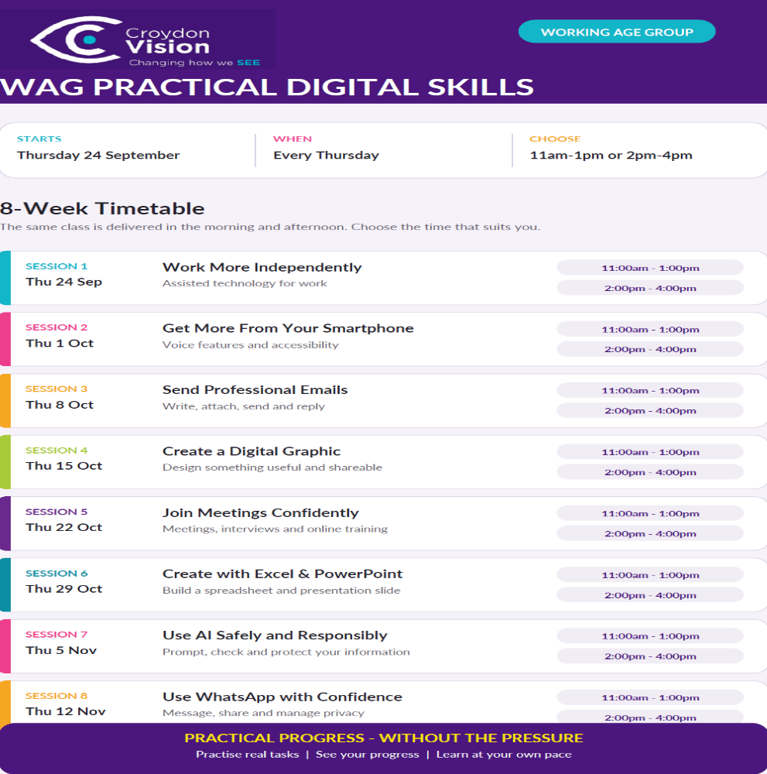
October:
October is black history and braille awareness month. On 14th October HumanWare will be showcasing the latest in braille technology. You will have to be here to try these technologies.

On 28th October, WAG will have a series of activities to mark Black History Month from poetry, music singing and a talk. Please put these dates in your diary and join us for a fun time.

Today's quote:
"Don't watch the clock; do what it does. Keep going." — Sam Levenson

This Quote Matters
Keep moving: Small, steady steps lead to big goals.
Stop waiting: Time passes anyway, so focus on your actions right now.

A: Bedford Hall, 72 - 74 Wellesley Road, Croydon, CR0 2AR
T: 020 8688 2486; Mob: 07395 247 699
E: ancella.george@croydonvision.org.uk | W: www.croydonvision.org.uk
Donate with JustGiving: https://www.justgiving.com/campaign/croydonvision

