Working Age Bulletin

Wednesday 14th October 2026

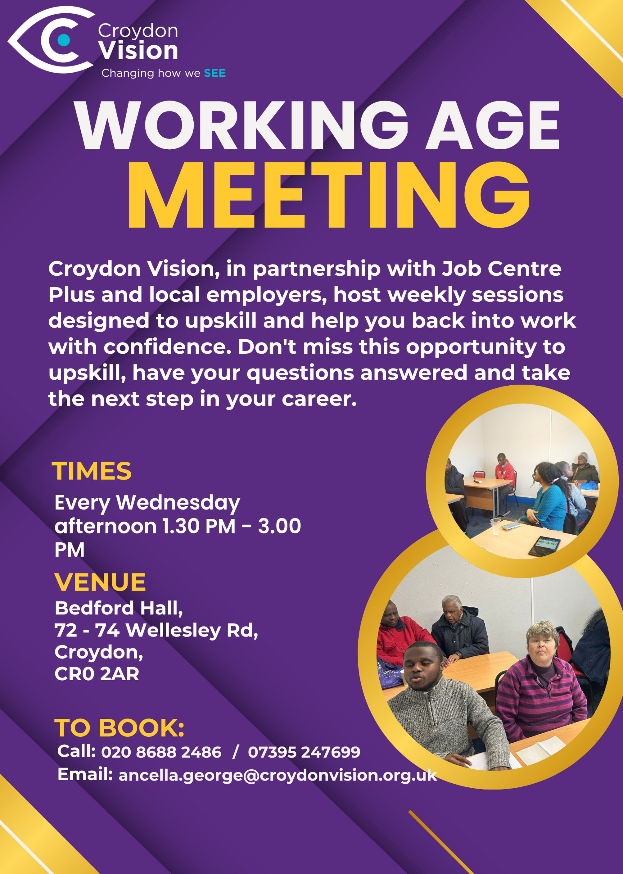


JustGiving Link:
https://www.justgiving.com/charity/croydonvisually

Weekly Meetings:
Bedford Hall 1.30pm – 3.00pm every Wednesday. Please arrive at 1.15pm for tea and coffee.

WAG Timetable:
Monday
ESL: 10.30am – 12.30pm – Bedford Lounge
Braille: 1.30pm – 3.00pm – Second Floor
Tuesday
Braille: 10.30am – 12.30pm – Second Floor
Knitting: 12.00 – 2.00pm – Lounge
Book Club: 1.30pm – 3.00pm – Second Floor
Wednesday
Braille: 10.30am – 12.30pm – Second Floor
Craft Skills: 10.00am – 1.00pm – Art Room
WAG: 1.30pm – 3.00pm – Bedford Hall

Itinerary for October:
14th October | Hosting HumanWare for Braille Awareness week
21st October | Black History Month Afternoon with special guests
Tuesday 27th October | SIGHT VILLAGE
28th October | Talk on Sickle Cell

Reminder - Croydon Safer Neighbourhood:
Croydon Safer Neighbourhood team is inviting you to an open house meeting to have your say on ‘Stop and Search - a community conversation’.

Date: Wednesday 14th October 2026
Place: The Family Centre, New Addington, CR0 9AZ
Time: 6.00pm – 8.00pm (doors open at 5.30pm)

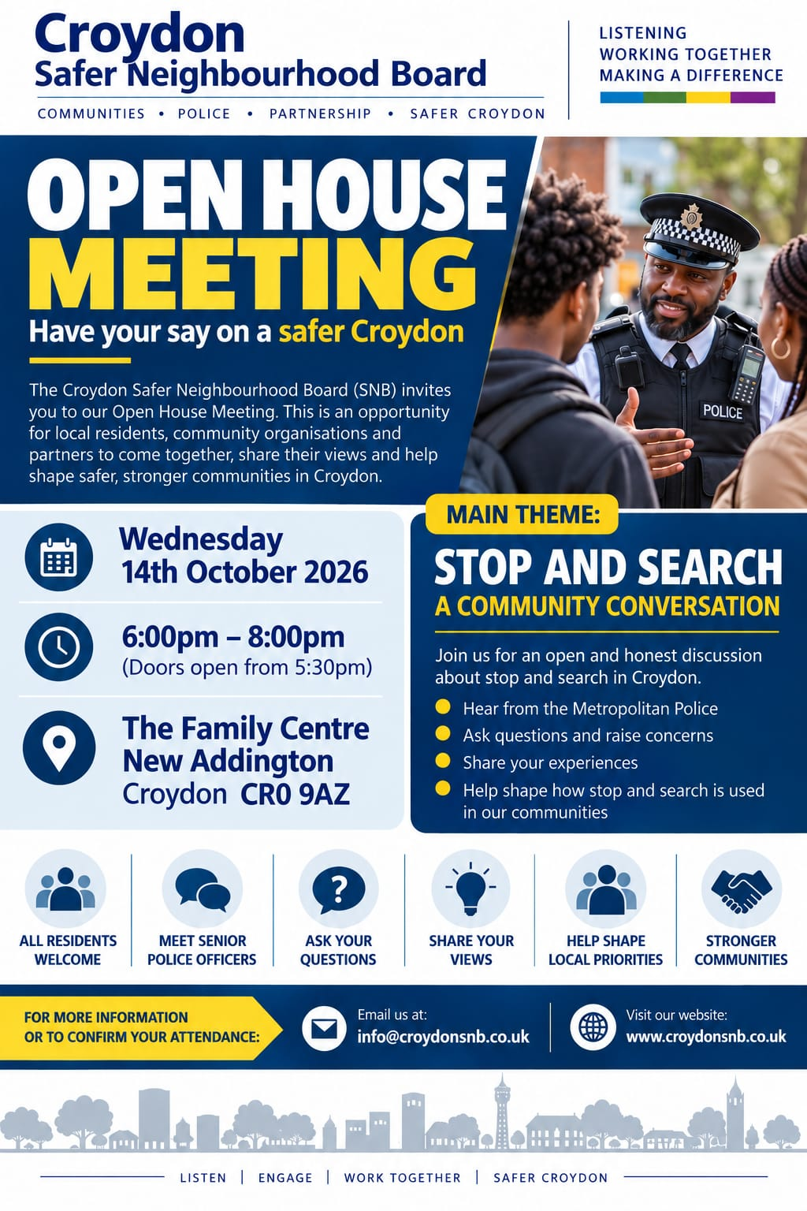

Black History Month:
We will be celebrating Black History Month next week Wednesday, 21st October, in the WAG session. We have some beautiful performers from inhouse as well as external guests such as a choir, a soloist, instrument players and poets. Please join us for a fun afternoon from 1.30pm – 3.00pm.

Croydon Culture - Celebrating Black women's stories, achievements and futures:
Her History, Our Stories, Collective Futures, brings together women of African, Caribbean and broader Black heritage for an uplifting afternoon of conversation, culture, connection and inspiration. Featuring guest speakers Lorlett Hudson FRSA and Anne-Marie Walker, the event creates space to reflect on the past, celebrate the present and look ahead to the future.
Date: Saturday 17 Oct, 12.00-4.00pm
The Front Room, Croydon
FIND OUT MORE & BOOK

Young Women’s Trust:
At Young Women’s Trust we have a programme called Navigating Work as Women of Colour. The workshops start next week, and we would appreciate your help in sharing it.

This free programme has been designed by and for women of colour. Workshops will take place on Zoom over three Thursday lunchtimes: 15th and 22nd October 2026, 12 - 2pm.

Young women will:
- Connect with and learn from other women of colour.
- Learn about their rights at work and how to advocate for themselves.
- Build confidence in their voice and contributions.
- Explore ways to navigate bias, microaggressions and workplace challenges.

Sign up here: Workshop Series | Young Women's Trust

Vacancies:
See below vacancies and information on how to apply:
Administration and Events Assistant Intern (Apprenticeship) at The Royal Free hospital
- Location: Hybrid: Royal Free Hospital, Pond Street, London NW3 2QG
- Salary: NHS Band 4 (apprenticeship)
- Contract type: Full time, 37.5 hours per week, Fixed Term, 22-month contract.
- Applications close: Friday 16th October
- For information and how to apply visit https://www.pocklington.org.uk/about-us/workattpt/

Admin Assistant vacancy at Devon in Sight
- Location: Splatford Barton, Kennford, Exeter, EX6 7XY (Office-based)
- Hours: 18 hours per week (worked across Monday to Thursday, 5 hours per day; flexible options considered)
- Salary: £12.85 per hour (£12,087 Per Annum | £25,060 FTE)
- For information and how to apply visit https://devoninsight.org.uk/about-us/join-our-team

Today's quote:
"Every accomplishment starts with a decision to try." — Gail Devers

A: Bedford Hall, 72 - 74 Wellesley Road, Croydon, CR0 2AR
T: 020 8688 2486; Mob: 07395 247 699
E: ancella.george@croydonvision.org.uk | W: www.croydonvision.org.uk
Donate with JustGiving: https://www.justgiving.com/campaign/croydonvision



